

AN ISO 9001:2015, 14001:2015, 21001:2018, 45001:2018 CERTIFIED TRAINING INSTITUTION

**NETTUR TECHNICAL EDUCATION CENTER**

**SYNOPSIS**

ON

# VEHICLE SERVICING SYSTEM

PROJECT DONE BY

**CHANDAN SINGH (RNTC0822008)**

MUNIKOTI BHARGAV KR. (RNTC0822026)

SURYA PRAKASH TIWARY (RNTC0822012)

SONAL SINGH (RNTC0822037)

**DIPLOMA IN COMPUTER ENGINEERING AND IT INFRASTRUCTURE**

NTTF AT R D TATA TECHNICAL EDUCATION CENTRE

GOLMURI, AGRICO POST, JAMSHEDPUR

2022 – 2025



AN ISO 9001:2015, 14001:2015, 21001:2018, 45001:2018 CERTIFIED TRAINING INSTITUTION

**NETTUR TECHNICAL TRAINING FOUNDATION**

***CERTIFICATE***

This is to certify that the project titled

# **VEHICLE SERVICING SYSTEM**

Is a bona fide record of the project work done by

**CHANDAN SINGH (RNTC0822008)**

MUNIKOTI BHARGAV KR. (RNTC0822026)

SURYA PRAKASH TIWARY (RNTC0822012)

SONAL SINGH (RNTC0822037)

In partial fulfilment of the requirement for the award of Diploma in Computer Engineering and IT Infrastructure under the institution Nettur Technical Training Foundation, Jamshedpur Training Centre, during the Academic year 2022 – 2025.

**PROJECT GUIDE EXTERNAL EXAMINER PRINCIPAL**

**ACKNOWLEDGEMENT**

**We hereby declare that we the members of the team “TECH OF TURTULE”, would like to accomplish our Web based project under the guidance of Mr. Mrinmoy Kumar Mahato. We are very thankful to Bibek Sir, Smruti Mam & Shilpa Mam all the Supporting Staff Members who helped and motivated us whenever required. We are very grateful to our Principal Madam, Mrs. Preeta John for giving us this golden chance to explore ourselves. Last but not the least, we would like to thank our Classmates who were ready to help us whenever required.**

**THANK YOU.**

**CONTENTS**

|  |  |  |
| --- | --- | --- |
| **SLNO** | **TOPICS** | **PAGES** |
| 1 | * INTRODUCTION TO VEHICLE SERVICING SYSTEM | 6-32 |
| 2 | * INTRODUCTION TO FLOW CHART & ER DIAGRAM & DFD | 33-45 |
| 3 | * REQUIREMENT TO MAKE THIS PROJECT | 46-56 |
| 4 | GANTT CHART | 57-60 |
| 5 | * CODING | 61-162 |
| 6 | * USER INTERFACE & ADMIN INTERFACE | 163-183 |
| 7 | * DATA STRUCTURE OF THE PROJECT | 184-227 |
| 8 | * BIBLOGRAPHY | 228-231 |
| 9 | * CONCLUSION | 232 |

**CHAPTER-1**

**Introduction to**

**“VEHICLE SERVICING SYSTEM”**

**INTRODUCTION TO PROJECT:-**

**A Vehicle Service System is a comprehensive framework or software solution designed to manage and streamline the maintenance, repair, and management of vehicles. It serves as a tool for vehicle owners, fleet managers, or auto service centre's to ensure vehicles are properly serviced, maintained, and repaired in a timely and efficient manner. The primary purpose of a vehicle service system is to track the performance and condition of vehicles, schedule maintenance, manage repairs, and ensure the overall safety, reliability, and longevity of the vehicles.**

**FEASIBILITY STUDY:-**

* **Market Feasibility:-**

Market feasibility refers to the process of determining if a product or service can be successfully launched and sustained in a particular market. It involves analyzing the market to assess potential demand, identify competition, and understand market trends to decide if there is a viable opportunity for the proposed project or business.

Here's a more detailed breakdown:

What it involves:

**Understanding Customer Needs and Preferences:**

Market feasibility studies aim to understand the needs and preferences of the target audience to ensure the product or service aligns with their requirements.

* **Assessing Market Demand:**

It involves analyzing the size of the market, its growth potential, and the overall demand for the proposed product or service.

* **Evaluating Competition:**

A key aspect of market feasibility is identifying and analyzing existing competitors to understand their strengths and weaknesses, market share, and pricing strategies.

* **Analyzing Market Trends**:

This includes understanding current trends, seasonality, and other factors that could impact the success of the product or service.

* **Financial Analysis:**

Assessing the financial viability of the project, including projected costs, revenue, and profitability.

**Why it's important:**

* **Informed Decision-Making:**

Market feasibility studies provide valuable insights to help entrepreneurs and businesses make informed decisions about launching a new product, service, or business venture.

* **Identifying Opportunities**:

These studies help identify potential opportunities and areas where there is a gap in the market that the proposed product or service can fill.

* **Minimizing Risk:**

By assessing the market landscape, businesses can reduce the risk of launching a product or service that won't be successful.

* **Strategic Planning:**

The results of a market feasibility study can be used to develop effective marketing and sales strategies.

In essence, market feasibility is a crucial step in the business planning process, helping to determine if a venture is likely to succeed in a given market.

* **Technical Feasibility**

Technical feasibility is an assessment of whether a project, product, or service can be successfully implemented using available technology, resources, and expertise. It involves evaluating the practicality of the technical aspects, such as system architecture, hardware and software requirements, technical skills, and integration with existing systems. Essentially, it determines if the technical requirements can be met given the available tools and resources.

Here's a more detailed breakdown:

* **Evaluation of Resources:**

Technical feasibility examines whether the necessary hardware, software, and technical skills are available to develop and implement the proposed solution.

* **Technology Assessment:**

It assesses the suitability and availability of existing technologies, or if new ones need to be developed or adopted.

* **System Integration:**

Technical feasibility considers how the new system will integrate with existing systems, including data compatibility, security, and potential disruptions.

* **Maintenance and Upgradability:**

It also evaluates the ease of maintenance, upgrades, and future development of the system.

* **Risk Assessment:**

Technical feasibility helps identify potential technological risks and challenges, and how to mitigate them.

* **Operational Feasibility**

Operational feasibility, in the context of feasibility studies, means assessing the practicality and suitability of a proposed project or system within an existing organizational or business environment. It examines whether the project can be successfully implemented and operated given the available resources, organizational structure, and willingness of stakeholders to use it.

Here's a more detailed breakdown:

* **Practicality and Suitability:**

Operational feasibility evaluates how well a proposed solution aligns with the day-to-day operations and processes of an organization.

* **Resource Availability:**

It considers the availability of human resources, physical assets (like equipment or infrastructure), and other resources necessary for the project.

* **Organizational Structure:**

The assessment looks at how the project can be integrated into the existing organizational structure, including roles, responsibilities, and communication channels.

* **Stakeholder Acceptance:**

It also examines the willingness of users, employees, and other stakeholders to adopt and utilize the new system or process.

* **Impact on Existing Operations:**

A key aspect is understanding how the project will impact existing workflows, procedures, and processes, and whether any significant changes or adjustments will be needed.

* **Usability:**

Operational feasibility also assesses the usability of the proposed solution, ensuring it is easy for users to understand and use effectively.

* **Financial Feasibility**

Financial feasibility refers to the assessment of whether a project or business idea is financially viable and can generate a positive return on investment. It involves analyzing the cost-benefit aspects,potential revenues, and associated risks to determine if the project is economically sound and can achieve the desired financial goals. In essence, it's about understanding if the project can generate enough money to cover its costs and provide a profit.

Here's a more detailed look at what financial feasibility encompasses:

Key aspects of a financial feasibility study:

* **Cost-benefit analysis:**

Evaluating the total cost of the project and comparing it to the expected benefits.

Revenue projections: Estimating the potential income the project will generate.

* **Return on Investment (ROI):**

Calculating the expected profit as a percentage of the initial investment.

* **Cash flow forecasts:**

Predicting the flow of money into and out of the project over time.

* **Risk assessment:**

Identifying and analyzing potential financial risks associated with the project.

**Why is financial feasibility important?**

* **Decision-making:**

Helps decision-makers determine if a project is worth pursuing.

* **Resource allocation:**

Guides the allocation of resources by identifying projects with the greatest potential

for financial success.

* **Investor confidence:**

Provides investors with the information they need to assess the potential risks and

rewards of a project.

* **Project viability:**

Ensures that projects are financially sound and sustainable.

* **Schedule Feasibility**

Schedule feasibility in a project context refers to the likelihood of completing the project

within the proposed timeline, considering factors like resource availability,dependencies,

and potential risks. It's a crucial part of a feasibility study that determines if a project

can be realistically achieved within the allotted time.

Key aspects of schedule feasibility:

* **Timeframe analysis:**

It involves examining whether the project's proposed timeline is realistic and achievable.

* **Resource assessment:**

It considers the availability and capacity of resources (like personnel, equipment, and materials) to meet the schedule.

* **Dependency evaluation:**

It identifies and analyzes relationships between different tasks within the project, ensuring they can be completed in a logical sequence within the timeframe.

* **Risk assessment:**

It identifies potential risks that could impact the schedule and assesses the likelihood and impact of these risks.

* **Project completion before obsolescence:**

It ensures the project is completed before it becomes outdated or no longer relevant.

Why schedule feasibility is important:

* **Project success:**

Meeting the schedule is crucial for project success, as delays can lead to increased costs, missed deadlines, and potentially the failure of the project.

* **Resource utilization:**

Properly assessing schedule feasibility helps optimize resource allocation, ensuring resources are used effectively and efficiently.

* **Stakeholder expectations:**

It helps manage stakeholder expectations by providing a clear understanding of the project timeline and the likelihood of meeting it.

* **Cost control:**

A realistic schedule can help prevent cost overruns caused by delays or rework.

* **Tools for schedule feasibility analysis:**

**Gantt charts:** Visual representation of project tasks and their timelines.

**PERT charts:** Techniques for estimating project durations and identifying critical paths.

**Risk analysis tools:** Methods for identifying and assessing potential risks that could impact the schedule.

**OBJECTIVE:**

The primary objective of a web-based Vehicle Servicing System is to provide a convenient and efficient platform for both customers and service centers to manage vehicle servicing. This includes online booking, appointment scheduling, and streamlined service management, aiming to improve the overall customer experience and operational efficiency.

Here's a more detailed breakdown of the objectives:

**For Customers:**

* **Online Booking and Appointment Scheduling:**

Customers can easily book appointments for services online, saving time and effort compared to manual methods.

* **Convenient Service Access:**

The system allows customers to access service information and book services from anywhere with an internet connection.

* **Clear Service Details:**

Customers can view available services, their costs, and other relevant information before booking.

* **Tracking and Updates:**

Customers can track the status of their vehicle service and receive updates through the system.

* **Improved Customer Experience:**

The system aims to make the entire servicing process more convenient and efficient for the customer.

* **For Service Centers:**

**Efficient Service Management:**

The system streamlines the process of managing appointments, tracking vehicles, and communicating with customers.

* **Reduced Manual Workload:**

By automating tasks like scheduling and communication, the system reduces manual workload for service center staff.

* **Improved Efficiency:**

The system helps service centers manage their resources and operations more efficiently, leading to faster turnaround times and higher productivity.

* **Better Customer Communication:**

The system facilitates better communication between service centers and customers, leading to improved customer satisfaction.

* **Data Management and Reporting:**

The system can help service centers track their performance, analyze data, and generate reports for better decision-making.

* **Enhanced Security:**

The system can ensure the secure storage and management of customer data.

**TARGET AUDIENCE:**

The primary target audience for a vehicle servicing system web-based project is vehicle owners, car garages, and service centers. Specifically, the project aims to benefit these stakeholders by offering convenient online booking, service scheduling, and management capabilities.

Here's a more detailed breakdown:

* **Vehicle Owners:**

They can use the system to book appointments, track service history, receive reminders, and manage their vehicle data.

* **Car Garages:**

The system can help them streamline their operations, manage customer data, track vehicle repairs, and improve their communication with customers.

* **Service Centers:**

Similar to garages, they can benefit from the system's ability to manage appointments, track service history, and provide better customer service.

**ADVANTAGES:**

A web-based vehicle servicing system offers several advantages over traditional paper-based systems. These include improved efficiency, reduced costs, and enhanced customer experience. A web-based system allows for online booking, real-time data access, and automated processes, leading to faster and more efficient service delivery.

Here's a more detailed look at the advantages:

* **Improved Efficiency:**

**Online Booking and Scheduling:**

Customers can easily book appointments and track their vehicle's progress online, reducing wait times and paperwork.

**Real-time Data Access:**

Mechanics and administrators can access vehicle records, service history, and customer information instantly, improving decision-making and reducing errors.

**Automated Processes:**

Tasks like invoicing, appointment reminders, and status updates can be automated, freeing up staff time for more complex tasks.

**Paperless Operation:**

Eliminating paper-based records reduces storage space, improves accessibility, and minimizes the risk of lost or damaged documents.

**Reduced Costs:**

Lower Operational Costs: Reduced paperwork and automated processes lead to lower overhead costs.

**Improved Resource Allocation:**

Real-time data insights enable better resource allocation, optimizing staffing and reducing overtime. Cost Savings on Repairs: Early detection of potential issues through routine maintenance can prevent more costly repairs later.

* **Enhanced Customer Experience:**

**Convenience:**

Customers can manage their vehicle servicing from anywhere, anytime, improving accessibility and convenience.

**Transparency:**

Customers can track their vehicle's service progress and see detailed reports online, fostering trust and confidence.

**Personalized Service:**

Systems can store customer preferences and service history, allowing for more personalized service.

**Automated Notifications:**

Customers can receive automated reminders for scheduled maintenance and service, improving adherence to maintenance schedules.

* **Additional Benefits:**

**Scalability:**

Web-based systems are easily scalable to accommodate growing business needs.

**Remote Access:**

Administrators and mechanics can access the system from anywhere with an internet connection, enabling remote work and collaboration.

**Improved Communication:**

Systems can facilitate communication between customers, service providers, and administrators, ensuring smooth and efficient service delivery.

**DISATVANTAGES:**

A web-based vehicle servicing system, while offering many benefits, also has disadvantages. These include potential security breaches, reliance on internet access, the need for skilled technical support, and the possibility of system downtime impacting operations. Additionally, the system might require significant initial investment and ongoing maintenance costs.

Here's a more detailed look at the disadvantages:

* **Security and Data Privacy:**

**Data breaches:**

Web-based systems are vulnerable to cyberattacks and data breaches, potentially exposing sensitive customer information like vehicle details, personal data, and payment information.

**Need for robust security measures:**

Implementing and maintaining strong security measures, such as encryption and firewalls, can be costly and complex, according to ResearchGate.

**Compliance with regulations:**

Meeting data privacy regulations (like GDPR) requires careful planning and implementation, adding to the complexity of the system.

* **Technical and Operational Issues:**

**Internet connectivity:**

The system's functionality is entirely dependent on a stable internet connection, which can be unreliable in certain areas or during network outages.

**System downtime:**

Unscheduled maintenance or system failures can lead to downtime, disrupting service bookings and access to crucial information.

**Technical support:**

A dedicated technical support team is needed to address issues, troubleshoot problems, and provide ongoing maintenance, according to IRJET.

**Skill requirements:**

Users need basic computer skills and internet literacy to effectively use the system, which can be a barrier for some individuals.

**Hardware requirements:**

Users need compatible devices and internet access, which may not be available to all.

* **Financial Considerations:**

**Initial investment:**

Developing and launching a web-based system requires significant upfront investment in software, hardware, and infrastructure, according to TrackoBit.

**Ongoing maintenance costs:**

Regular system updates, security patches, and technical support add to the ongoing costs of the system.

**Cost of training:**

Staff need training to effectively use the system, adding to the initial and ongoing costs, according to IRJET.

* **Other Considerations:**

**User interface:**

A well-designed user interface is crucial for ease of use, but poor design can lead to frustration and reduced adoption, according to IRJET.

**Scalability:**

The system needs to be scalable to accommodate growing customer base and data volume, which requires careful planning and implementation.

**Data storage:**

Managing and storing large volumes of vehicle data requires robust and secure storage solutions, adding to the overall complexity and cost.

**FUNCTIONALITIES:**

### **1. Vehicle Maintenance Scheduling**

This feature allows workshops or fleet managers to **plan and manage regular maintenance tasks** to prevent vehicle breakdowns and ensure optimal performance.

* **Automatic Reminders:** Sends alerts to customers when a vehicle is due for maintenance based on mileage, engine hours, or time intervals.
* **Recurring Appointments:** Allows setting recurring service schedules (e.g., every 5,000 miles).
* **Technician Allocation:** Assigns technicians automatically or manually based on availability.
* **Calendar View:** Provides a visual calendar to manage appointments efficiently and avoid overbooking.

### **2. Parts Management and Inventory**

This module manages **spare parts, consumables, and inventory levels**, ensuring the right parts are in stock when needed.

* **Stock Tracking:** Tracks real-time inventory levels and parts movement.
* **Supplier Integration:** Manages supplier contacts, pricing, and lead times.
* **Reorder Alerts:** Sends alerts when stock levels fall below a predefined threshold.
* **Part Usage Reports:** Tracks frequently used parts to optimize future orders and reduce overstocking.

### **3. Customer Management and Communication**

Helps maintain **comprehensive customer profiles** and improves communication between the service center and clients.

* **Contact Records:** Stores customer contact info, vehicle details, and service preferences.
* **Communication Tools:** Sends updates via SMS, email, or push notifications (e.g., appointment reminders, service completion notices).
* **Service History Access:** Allows customers to view their vehicle’s service history via a portal or app.
* **Feedback Collection:** Facilitates post-service surveys or reviews to gather customer feedback.

### **4. Vehicle Inspection and Monitoring**

Facilitates **detailed inspections of vehicles** before, during, and after service.

* **Inspection Checklists:** Pre-built or customizable digital checklists for various vehicle types.
* **Photo and Video Capture:** Allows technicians to attach photos or videos of damage or repairs.
* **Diagnostic Tools Integration:** Interfaces with OBD-II scanners or telematics for real-time data.
* **Inspection Reports:** Generates reports that can be shared with customers for transparency.

### **5. Cost Estimation and Billing**

Provides tools for **creating cost estimates, billing customers, and processing payments**.

* **Automated Estimates:** Uses labor rates, parts prices, and taxes to generate accurate quotes.
* **Customer Approvals:** Allows customers to approve or reject estimates digitally.
* **Invoicing:** Generates itemized invoices including labor, parts, taxes, and discounts.
* **Multi-Payment Options:** Accepts payments via credit card, cash, mobile wallets, or integrated finance options.

### **6. Repair Management**

Tracks the **entire lifecycle of repair jobs**, from intake to completion.

* **Work Orders:** Creates detailed work orders listing required tasks and assigned technicians.
* **Time Tracking:** Monitors how long each job takes, helping with productivity analysis.
* **Status Updates:** Changes job status (e.g., Pending, In Progress, Completed) in real-time.
* **Internal Notes:** Allows technicians to leave comments or notes for other team members.

### **7. Reporting and Analytics**

Provides **data insights and visual reports** to support business decisions and performance tracking.

* **Service Trends:** Tracks which services are most in-demand.
* **Technician Performance:** Analyzes work completion times, quality, and efficiency.
* **Financial Reports:** Offers revenue, expense, and profit analysis.
* **Custom Dashboards:** Tailored views for managers, accountants, or customer service reps.

### **8. Mobile and Remote Access**

Enables both **technicians and customers** to interact with the system remotely via smartphones, tablets, or laptops.

* **Mobile App for Technicians:** Allows updates from the shop floor, including clocking in/out, marking tasks as complete, or uploading inspection media.
* **Customer Portal/App:** Lets customers schedule appointments, approve estimates, and track repair status.
* **Cloud-Based Access:** Ensures the system can be used anywhere with an internet connection.
* **Offline Functionality:** Some platforms support offline access with automatic syncing later.

### **9. Maintenance History and Warranty Tracking**

Keeps a **comprehensive record of all past services and warranty information**, useful for compliance and resale value.

* **Service Records:** Tracks every repair, replacement, and check-up a vehicle has undergone.
* **Warranty Expiration Alerts:** Notifies both staff and customers about expiring part or service warranties.
* **Historical Reports:** Provides complete maintenance logs to support resale or audits.
* **Integration with OEM Data:** Matches manufacturer service recommendations with actual service history.

**AGILE METHODOLOGY**

**Agile methodology** is a flexible, collaborative, and iterative approach to **project development**, especially common in **software engineering** and **product management**. It emphasizes **responding to change**, **delivering small, working pieces of a project quickly**, and **continuous improvement through feedback**.

### 🔍 Definition of Agile Methodology

Agile is not a specific process or tool — it’s a **set of values and principles** outlined in the [Agile Manifesto (2001)](https://agilemanifesto.org/), which values:

* **Individuals and interactions** over processes and tools
* **Working software** over comprehensive documentation
* **Customer collaboration** over contract negotiation
* **Responding to change** over following a fixed plan

### 🛠️ Key Features of Agile

| Feature | Explanation |
| --- | --- |
| **Iterative development** | Work is delivered in small chunks called **iterations** or **sprints** (usually 1–4 weeks long). |
| **Frequent delivery** | A working product is released regularly, not just at the end of the project. |
| **Customer feedback** | Stakeholders are involved regularly to give feedback and adjust priorities. |
| **Cross-functional teams** | Developers, testers, designers, and product owners work closely together. |
| **Adaptive planning** | Plans change as the team learns more about the product or market. |

### ✅ Why Agile Is Used in Project Development

|  |  |
| --- | --- |
| **Faster time to market** | You deliver working features quickly, even if the full product isn't ready. |
| **Flexibility** | You can change scope, features, or direction mid-project without chaos. |
| **Improved quality** | Continuous testing and frequent feedback loops help catch issues early. |
| **Customer satisfaction** | The customer is involved, sees progress often, and gets to influence outcomes. |
| **Better risk management** | Problems are visible early, not just at the end. |
| **Higher team engagement** | Self-organizing teams take ownership and continuously improve. |

### 🧰 **Popular Agile Frameworks**

Agile is a philosophy — several **frameworks** implement it:

| **Framework** | **Description** |
| --- | --- |
| **Scrum** | Most popular. Uses roles (Scrum Master, Product Owner), sprints, daily stand-ups. |
| **Kanban** | Visual task board (To Do → In Progress → Done), focused on flow and limiting work in progress. |
| **Extreme Programming (XP)** | Emphasizes coding practices like pair programming, test-driven development. |
| **SAFe (Scaled Agile Framework)** | Applies Agile at enterprise scale. |



**HTML (Hyper Text Markup Language) – A Comprehensive Definition**

HTML (HyperText Markup Language) is the foundational language used to create and structure web pages on the internet. It provides a standardized way to organize content, ensuring that web browsers like Google Chrome, Mozilla Firefox, and Microsoft Edge can interpret and display it correctly. HTML is not a programming language but a markup language that structures web content through a system of elements and tags.

**Key Features of HTML**

1. **Tag-Based Markup Language**  
   HTML uses tags enclosed in angle brackets (<>) to define elements. Most tags have an opening (<tag>) and a closing (</tag>) counterpart, except for self-closing tags like <img> and <br>.
2. **Hyperlinks and Navigation**  
   The <a> tag allows users to navigate between different web pages using hyperlinks.
3. **Multimedia Integration**  
   HTML supports embedding images (<img>), audio (<audio>), and video (<video>) to enhance user experience.
4. **Forms and User Input**  
   The <form> tag, combined with elements like <input>, <textarea>, and <button>, enables user interactions such as login forms, search bars, and feedback submissions.
5. **Tables and Lists**  
   HTML provides <table> for organizing data in rows and columns, and <ul> or <ol> for creating bullet or numbered lists.



**CSS (Cascading Style Sheets) – A Comprehensive Definition**

CSS (Cascading Style Sheets) is a stylesheet language used to describe the presentation and layout of web pages. It controls how HTML elements appear on the screen, including aspects like colors, fonts, spacing, positioning, and animations. By separating content (HTML) from design (CSS), it enhances web development efficiency, making websites visually appealing and user-friendly.

**The Role of CSS in Web Development**

CSS plays a critical role in modern web design by allowing developers to:

* Control the look and feel of web pages.
* Apply consistent styling across multiple pages.
* Improve website responsiveness for different screen sizes.
* Enhance user experience with animations and transitions.

CSS works alongside HTML and JavaScript to build dynamic, attractive websites.

**CSS3 and Its Advancements**

CSS3 introduced modern features such as:

* **New Selectors** (nth-child, not())
* **Flexbox and Grid Layouts**
* **Custom Fonts (@font-face)**
* **Improved Animation Capabilities**
* 

**JavaScript (JS) – A Comprehensive Definition**

JavaScript (JS) is a high-level, interpreted programming language that enables dynamic and interactive web content. It is one of the core technologies of web development, alongside **HTML (HyperText Markup Language)** and **CSS (Cascading Style Sheets)**. While HTML structures a webpage and CSS styles it, JavaScript adds interactivity, making it more engaging for users.

Initially designed for web browsers, JavaScript has evolved into a versatile language that powers web applications, mobile apps, server-side applications (via **Node.js**), and even game development.

**The Role of JavaScript in Web Development**

JavaScript enhances webpages by enabling:

* **Interactivity** – Animations, dropdown menus, modals, and form validations.
* **Dynamic Content Updates** – Without reloading the page, using technologies like **AJAX** and **Fetch API**.
* **Event Handling** – Detecting and responding to user actions like clicks and keypresses.
* **DOM Manipulation** – Changing webpage content dynamically using the **Document Object Model (DOM)**.
* **Browser API Integration** – Accessing storage, geolocation, notifications, and more.



**PHP (Hypertext Preprocessor) – A Comprehensive Definition**

PHP (Hypertext Preprocessor) is a widely used, open-source server-side scripting language designed primarily for web development. It enables dynamic content creation, database interactions, and server-side functionalities, making it a key component in web applications. PHP scripts are executed on the server, and the resulting HTML is sent to the client’s browser.

PHP was originally created by Rasmus Lerdorf in 1994 and has since evolved into a powerful language with extensive support for databases, security, and scalability. It is commonly used in combination with **HTML, CSS, JavaScript, and MySQL** to develop full-fledged web applications.

**The Role of PHP in Web Development**

PHP is an essential backend language used for:

* **Generating Dynamic Web Pages** – Creating personalized content for users.
* **Handling Form Data** – Processing user inputs securely.
* **Database Connectivity** – Storing and retrieving data using databases like MySQL, PostgreSQL, and MongoDB.
* **User Authentication** – Managing logins, sessions, and security features.
* **File Handling** – Uploading and managing files on the server.
* **API Development** – Creating RESTful APIs to integrate with front-end frameworks like React or Vue.js.



**MySQLi (MySQL Improved) – A Comprehensive Definition**

**MySQLi (MySQL Improved)** is an extension of PHP that provides an enhanced interface for interacting with MySQL databases. It was introduced in **PHP 5.0** as an improvement over the older **MySQL extension**, offering better performance, security, and support for **prepared statements**, **transactions**, and **object-oriented programming (OOP)**.

Developers use MySQLi to **connect, query, and manipulate** databases efficiently. It is one of the two main options for database interaction in PHP, with the other being **PDO (PHP Data Objects)**. MySQLi is **MySQL-specific**, whereas PDO supports multiple database types.

**Key Features of MySQLi**

MySQLi offers several advantages over the old MySQL extension:

1. **Supports Both Procedural and Object-Oriented Approaches** – Allows developers to use the style they prefer.
2. **Prepared Statements** – Enhances security by preventing **SQL injection**.
3. **Transactions and Rollbacks** – Ensures data integrity during complex operations.
4. **Multiple Query Execution** – Supports batch queries for efficiency.
5. **Enhanced Debugging Capabilities** – Provides detailed error messages.

**Connecting to a MySQL Database Using MySQLi**

There are **two ways** to use MySQLi in PHP:

* **Procedural Style**
* **Object-Oriented Style**



**XAMPP** is a **free and open-source** cross-platform web server solution stack package developed by **Apache Friends**. It provides a **local web server environment** to help developers test and deploy web applications on their own computers before moving them to a live server.

The name **XAMPP** is an acronym:

* **X** = Cross-platform (works on Windows, macOS, and Linux)
* **A** = Apache (web server)
* **M** = MySQL / MariaDB (database server)
* **P** = PHP (server-side scripting language)
* **P** = Perl (another scripting language)

## 🔧 Components of XAMPP

1. **Apache**
   * The core of XAMPP; a widely-used open-source **web server**.
   * It serves web pages to users in response to HTTP requests.
2. **MySQL / MariaDB**
   * A powerful and popular **relational database** management system.
   * Stores data for your web applications (user info, posts, content, etc.).
3. **PHP**
   * A widely-used **server-side scripting language**.
   * Processes dynamic content and communicates with the database.
4. **Perl**
   * A scripting language used for web development and network programming (less common today, but still supported).
5. **phpMyAdmin**
   * A web-based interface to **manage MySQL databases**.
   * Allows you to run queries, manage tables, import/export data, etc.
6. **FileZilla FTP Server**
   * Provides FTP (File Transfer Protocol) access to upload/download files.
7. **Mercury Mail Server**
   * Sends/receives emails via PHP scripts (for contact forms, etc.).
8. **Tomcat**
   * Apache's server for running **Java-based applications** (optional component).

## 💡 Uses of XAMPP

### 1. **Local Development Server**

* Developers use XAMPP to run **PHP websites locally** on their computer before deploying to a live server.
* No internet required — just localhost access.

### 2. **Testing and Debugging**

* Ideal for **testing web apps**, fixing bugs, or trying new features in a safe, private environment.

### 3. **Database Management**

* You can create and manage databases using **phpMyAdmin**, perform queries, backups, and restorations.

### 4. **Learning and Education**

* Perfect for students and beginners learning **web development**, PHP, SQL, and server-side programming.

### 5. **CMS Installation and Testing**

* Easily install platforms like **WordPress**, **Drupal**, or **Joomla** locally using XAMPP.

### 6. **Simulating a Production Server**

* XAMPP mimics real server conditions (LAMP stack), helping simulate how your app will behave online.



**GitHub** is a **web-based platform** used for **version control** and **collaborative software development**. It’s built around **Git**, a distributed version control system created by **Linus Torvalds** (the creator of Linux).

### 🔹 Key Features

* **Repositories**: Central storage for code, documentation, and version history.
* **Commits**: Save points or changes in your code.
* **Branches**: Copies of your codebase where you can develop features or fixes in isolation.
* **Pull Requests (PRs)**: Proposals to merge changes from one branch into another, often reviewed and discussed before merging.
* **Issues**: Track bugs, feature requests, or tasks.
* **Actions**: Automate workflows like testing, building, and deploying code (CI/CD).
* **Wikis & Discussions**: Collaborative documentation and communication tools.
* **GitHub Pages**: Host static websites directly from a repository.

### 🔹 Common Use Cases

* **Open Source Projects**
* **Private Team Collaboration**
* **DevOps & CI/CD Pipelines**
* **Documentation and Wikis**
* **Code Review and Issue Tracking**

### 🔹 GitHub vs. Git

* **Git** is the underlying version control tool.
* **GitHub** is a platform that enhances Git by adding collaboration, GUI, and cloud features.

### 🔹 Popular Alternatives

* GitLab
* Bitbucket
* Azure DevOps

**CHAPTER-2**

**Introduction to**

**“FLOW CHART & ER DIAGRAM & DFD”**

**FLOW CHART:-**

A **flowchart** is a **diagram that represents a process**, system, or workflow using different symbols to denote steps, decisions, inputs/outputs, and flow direction. It visually maps how a process flows from beginning to end.

## **Types of Flowcharts**

### **Process Flowchart**

* + Most common.
  + Used to detail a sequence of business or technical activities.
  + Example: Step-by-step workflow of vehicle servicing.

### **Swimlane Flowchart**

* + Divides responsibilities across departments or roles.
  + Helps visualize which team/role does what in a process.
  + Example: Technician vs. Customer Service tasks.

### **Workflow Diagram**

* + Focuses on how a task flows through an organization.
  + Useful for approvals, handoffs, and progress tracking.

### **Data Flow Diagram (DFD)**

* + Shows how data flows between systems, processes, and storage.
  + Example: How service history flows between modules.

### **Decision Flowchart**

* + Heavily uses decision diamonds.
  + Useful for troubleshooting or guided choices.

Here are the five most common shapes used in a flowchart.

* Oval (Terminal symbol)
* Rectangle (Process symbol)
* Arrow (Arrow Symbol)
* Diamond (Decision symbol)
* Parallelogram (Input/Output symbol)

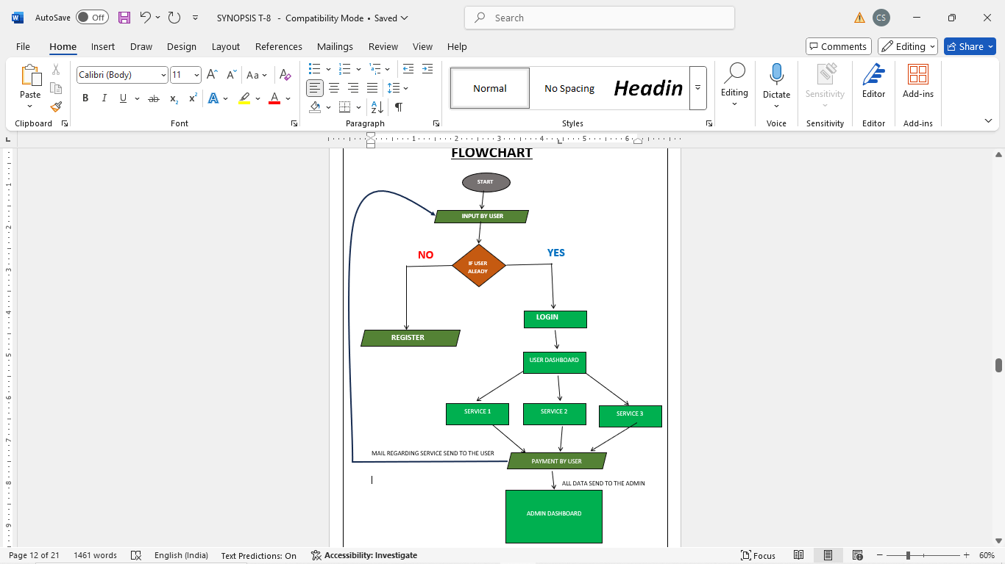

**ER-DIAGRAM:-**

An **ER Diagram (Entity-Relationship Diagram)** is a **visual representation of the data model** used to describe the **structure of a database**. It shows:

* **Entities** – Objects or concepts (e.g., Customer, Vehicle)
* **Attributes** – Information about the entities (e.g., Customer Name, Vehicle Model)
* **Relationships** – How entities are connected (e.g., A Customer *owns* a Vehicle)

## **Types of ER Diagrams**

### 1. **Conceptual ER Diagram**

* High-level view of the system.
* Focuses on business entities and their relationships.
* Does **not** include primary/foreign keys.
* **Used by:** Business analysts, early-stage design.

### 2. **Logical ER Diagram**

* More detailed, includes attributes and keys.
* Independent of specific database platforms.
* Includes **primary keys**, **foreign keys**, and **entity relationships**.
* **Used by:** Database designers.

### 3. **Physical ER Diagram**

* Maps the **logical design** into an actual **database schema**.
* Includes **table names**, **column types**, and **constraints**.
* Platform-specific (e.g., MySQL, Oracle).
* **Used by:** Database administrators (DBAs), developers.

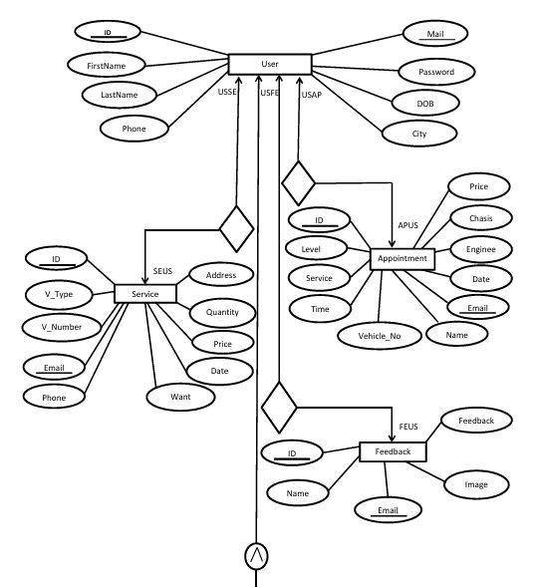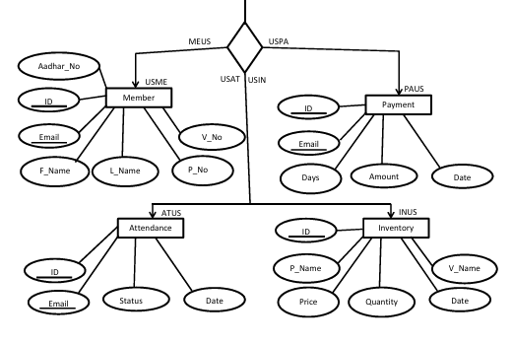

**DFD(DATA FLOW DIAGRAM):-**

A **Data Flow Diagram (DFD)** is a **graphical representation** that shows how **data flows** through a system. It illustrates:

* **Processes** (what the system does)
* **Data stores** (where data is stored)
* **Data sources/destinations** (external entities)
* **Data flows** (how data moves between parts)

## 🔹 **Key DFD Components**

| **Component** | **Description** | **Symbol** |
| --- | --- | --- |
| **Process** | Activity or function that transforms data | Circle or Rounded rectangle |
| **Data Flow** | Movement of data between entities/processes | Arrow |
| **Data Store** | Place where data is held | Open-ended rectangle |
| **External Entity** | Outside source or receiver of data | Rectangle |

## 📘 **Types of DFD**

### 1. **Context-Level DFD (Level 0)**

* **Highest-level view** of the system.
* Shows the **entire system as a single process**.
* Includes external entities and major data flows.
* **Purpose:** Gives a quick overview.

### 2. **Level 1 DFD**

* Breaks down the single process from Level 0 into **sub-processes**.
* Shows **main functional areas** and **data stores**.
* **Purpose:** Provides more detail on the system's functionality.

### 3. **Level 2 (and beyond) DFD**

* Further breakdown of Level 1 processes into **more detailed sub-processes**.
* Continues as needed to fully describe the system.
* **Purpose:** Detailed design and analysis.

**DFD-0:-**

**DFD Level 0** is the **highest-level view** of a system in a Data Flow Diagram. It represents the **entire system as a single process** and shows how it interacts with **external entities** (like users or other systems).

## 🔹 **Purpose of DFD Level 0**

* To provide a **big-picture overview** of the system.
* To identify the **main external entities** and the **data flowing in and out** of the system.
* To serve as a starting point for creating more detailed DFDs (like Level 1 or Level 2).

## 🔹 **Key Components in DFD Level 0**

| **Component** | **Role** | **Symbol** |
| --- | --- | --- |
| **Single Process** | Represents the entire system (e.g., "Vehicle Service System") | Circle or oval |
| **External Entities** | Outside sources or receivers of data (e.g., Customer, Supplier) | Rectangles |
| **Data Flows** | Arrows showing data moving to/from entities and the process | Arrows |

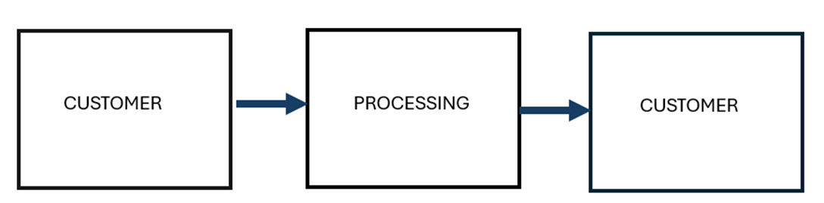

**DFD-1:-**

**DFD Level 1** is a **more detailed version** of the **Context-Level DFD (Level 0)**. It breaks down the single high-level process into **multiple sub-processes** to show **how the system works internally**.

## 🔹 **Purpose of DFD Level 1**

* To provide **functional details** about the main process shown in Level 0.
* To show **internal processes**, **data stores**, and **detailed data flows** between components.
* To support **system design, analysis, and development**.

## 🔹 **Key Components of DFD Level 1**

| **Component** | **Description** | **Symbol** |
| --- | --- | --- |
| **Sub-Processes** | Logical groupings of tasks (e.g., "Schedule Appointment", "Generate Invoice") | Circles/Ovals |
| **External Entities** | Same as in Level 0 (e.g., Customer, Inventory System) | Rectangles |
| **Data Stores** | Places where data is held or retrieved (e.g., Service Records, Parts Inventory) | Open-ended rectangles |
| **Data Flows** | Arrows showing movement of data | Arrows |

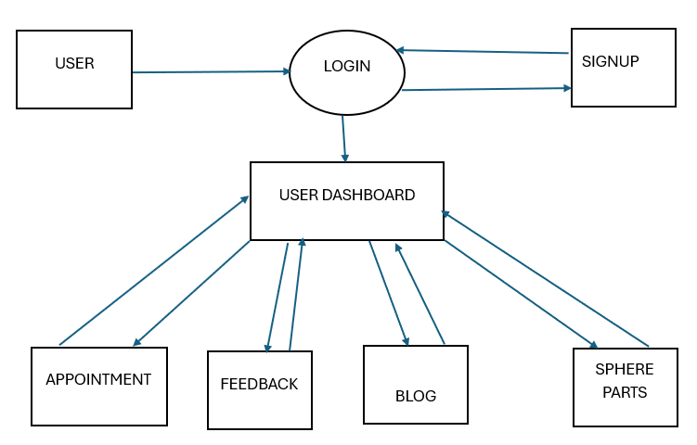

**DFD-2:-**

**DFD Level 2** is a **further breakdown** of a specific **sub-process** from **DFD Level 1**. It shows even **more detailed internal processes**, **data flows**, and **data stores** involved in that sub-process.

**You do not create a full DFD Level 2 for the entire system—only for one specific process from Level 1.**

## 🔹 **Purpose of DFD Level 2**

* To explain a **single sub-process** in fine detail.
* To help in **system design and development** by clarifying how individual tasks are handled.
* Useful for **complex processes** that need more explanation than Level 1 provides.

## 🔹 **Key Features of DFD Level 2**

| **Feature** | **Description** |
| --- | --- |
| **Focus** | One specific process from Level 1 |
| **Detail Level** | High (breaks process into individual tasks) |
| **Includes** | Sub-processes, data stores, data flows, entities |
| **When to Use** | When a Level 1 process is too complex |

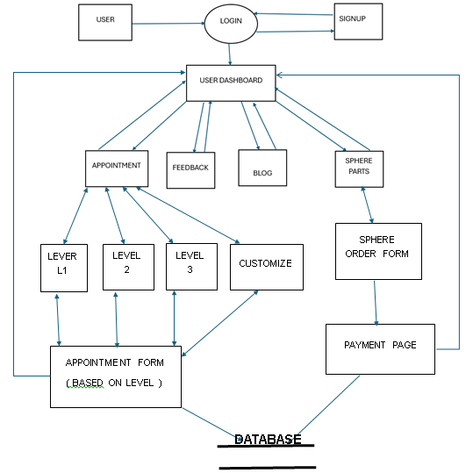

**CHAPTER-3**

**“REQUIREMENT TO MAKE THIS PROJECT”**

**REQUIREMENTS:**

* **VISUAL STUDIO:**

**Visual Studio** is an integrated development environment (IDE) developed by Microsoft. It is a powerful tool designed for creating computer programs, websites, web apps, web services, and mobile apps. Visual Studio supports a wide range of programming languages and development platforms, providing developers with a rich set of tools to write, debug, and deploy code efficiently.

### Key Features of Visual Studio

1. **Multi-language Support:**  
   Visual Studio supports languages such as C#, VB.NET, C++, Python, JavaScript, TypeScript, F#, and more. It also supports cross-platform development for Windows, Linux, Android, iOS, and web applications.
2. **Code Editor:**  
   The editor provides syntax highlighting, code completion (IntelliSense), code snippets, and refactoring tools. IntelliSense helps by predicting what the developer is typing and offering suggestions, making coding faster and less error-prone.
3. **Debugging:**  
   Visual Studio offers powerful debugging tools, including breakpoints, watch windows, call stacks, and step-through execution. It supports debugging for local code, remote servers, and even for live applications in production environments.
4. **Designer Tools:**  
   It includes visual designers for building graphical user interfaces (GUIs) such as Windows Forms, WPF (Windows Presentation Foundation), and Xamarin.Forms for mobile apps.
5. **Integrated Source Control:**  
   Visual Studio seamlessly integrates with version control systems like Git and Team Foundation Server (TFS), making it easier to manage source code versions and collaborate with teams.
6. **Extensions and Customization:**  
   Developers can extend Visual Studio’s capabilities through a vast marketplace of plugins and extensions, including support for additional languages, frameworks, tools, and utilities.
7. **Testing Tools:**  
   It provides integrated unit testing frameworks and tools to run automated tests, analyze code coverage, and improve software quality.
8. **Collaboration Tools:**  
   Features like Live Share allow multiple developers to collaborate in real-time on the same codebase, regardless of physical location.

### Uses of Visual Studio

* **Software Development:**  
  Writing applications for desktop, web, cloud, mobile, gaming, and IoT devices.
* **Web Development:**  
  Building websites and web apps using frameworks like ASP.NET, React, Angular, and Node.js.
* **Mobile App Development:**  
  Creating apps for Android and iOS using Xamarin or MAUI within Visual Studio.
* **Game Development:**  
  Using Unity or Unreal Engine plugins integrated into Visual Studio for game creation.
* **Cloud Services:**  
  Developing and deploying applications and services to Microsoft Azure directly from the IDE.
* **Data Science and AI:**  
  Writing Python and R code, integrating Jupyter notebooks, and working with machine learning models.
* **DevOps and CI/CD:**  
  Automating build, test, and deployment pipelines with integration to Azure DevOps and other CI/CD tools.
* **XAMPP SERVER**

**XAMPP** is a **free and open-source** cross-platform web server solution stack package developed by **Apache Friends**. It provides a **local web server environment** to help developers test and deploy web applications on their own computers before moving them to a live server.

The name **XAMPP** is an acronym:

* **X** = Cross-platform (works on Windows, macOS, and Linux)
* **A** = Apache (web server)
* **M** = MySQL / MariaDB (database server)
* **P** = PHP (server-side scripting language)
* **P** = Perl (another scripting language)

## 🔧 Components of XAMPP

1. **Apache**
   * The core of XAMPP; a widely-used open-source **web server**.
   * It serves web pages to users in response to HTTP requests.
2. **MySQL / MariaDB**
   * A powerful and popular **relational database** management system.
   * Stores data for your web applications (user info, posts, content, etc.).
3. **PHP**
   * A widely-used **server-side scripting language**.
   * Processes dynamic content and communicates with the database.
4. **Perl**
   * A scripting language used for web development and network programming (less common today, but still supported).
5. **phpMyAdmin**
   * A web-based interface to **manage MySQL databases**.
   * Allows you to run queries, manage tables, import/export data, etc.
6. **FileZilla FTP Server**
   * Provides FTP (File Transfer Protocol) access to upload/download files.
7. **Mercury Mail Server**
   * Sends/receives emails via PHP scripts (for contact forms, etc.).
8. **Tomcat**
   * Apache's server for running **Java-based applications** (optional component).

## 💡 Uses of XAMPP

### 1. **Local Development Server**

* Developers use XAMPP to run **PHP websites locally** on their computer before deploying to a live server.
* No internet required — just localhost access.

### 2. **Testing and Debugging**

* Ideal for **testing web apps**, fixing bugs, or trying new features in a safe, private environment.

### 3. **Database Management**

* You can create and manage databases using **phpMyAdmin**, perform queries, backups, and restorations.

### 4. **Learning and Education**

* Perfect for students and beginners learning **web development**, PHP, SQL, and server-side programming.

### 5. **CMS Installation and Testing**

* Easily install platforms like **WordPress**, **Drupal**, or **Joomla** locally using XAMPP.

### 6. **Simulating a Production Server**

* XAMPP mimics real server conditions (LAMP stack), helping simulate how your app will behave online.
* **HTML**

**HTML (Hyper Text Markup Language) – A Comprehensive Definition**

HTML (HyperText Markup Language) is the foundational language used to create and structure web pages on the internet. It provides a standardized way to organize content, ensuring that web browsers like Google Chrome, Mozilla Firefox, and Microsoft Edge can interpret and display it correctly. HTML is not a programming language but a markup language that structures web content through a system of elements and tags.

**Key Features of HTML**

1. **Tag-Based Markup Language**  
   HTML uses tags enclosed in angle brackets (<>) to define elements. Most tags have an opening (<tag>) and a closing (</tag>) counterpart, except for self-closing tags like <img> and <br>.
2. **Hyperlinks and Navigation**  
   The <a> tag allows users to navigate between different web pages using hyperlinks.
3. **Multimedia Integration**  
   HTML supports embedding images (<img>), audio (<audio>), and video (<video>) to enhance user experience.
4. **Forms and User Input**  
   The <form> tag, combined with elements like <input>, <textarea>, and <button>, enables user interactions such as login forms, search bars, and feedback submissions.
5. **Tables and Lists**  
   HTML provides <table> for organizing data in rows and columns, and <ul> or <ol> for creating bullet or numbered lists.

* **CSS**

**CSS (Cascading Style Sheets) – A Comprehensive Definition**

CSS (Cascading Style Sheets) is a stylesheet language used to describe the presentation and layout of web pages. It controls how HTML elements appear on the screen, including aspects like colors, fonts, spacing, positioning, and animations. By separating content (HTML) from design (CSS), it enhances web development efficiency, making websites visually appealing and user-friendly.

**The Role of CSS in Web Development**

CSS plays a critical role in modern web design by allowing developers to:

* Control the look and feel of web pages.
* Apply consistent styling across multiple pages.
* Improve website responsiveness for different screen sizes.
* Enhance user experience with animations and transitions.

CSS works alongside HTML and JavaScript to build dynamic, attractive websites.

**CSS3 and Its Advancements**

CSS3 introduced modern features such as:

* **New Selectors** (nth-child, not())
* **Flexbox and Grid Layouts**
* **Custom Fonts (@font-face)**
* **Improved Animation Capabilities**
* **JAVASCRIPT**

**JavaScript (JS) – A Comprehensive Definition**

JavaScript (JS) is a high-level, interpreted programming language that enables dynamic and interactive web content. It is one of the core technologies of web development, alongside **HTML (HyperText Markup Language)** and **CSS (Cascading Style Sheets)**. While HTML structures a webpage and CSS styles it, JavaScript adds interactivity, making it more engaging for users.

Initially designed for web browsers, JavaScript has evolved into a versatile language that powers web applications, mobile apps, server-side applications (via **Node.js**), and even game development.

**The Role of JavaScript in Web Development**

JavaScript enhances webpages by enabling:

* **Interactivity** – Animations, dropdown menus, modals, and form validations.
* **Dynamic Content Updates** – Without reloading the page, using technologies like **AJAX** and **Fetch API**.
* **Event Handling** – Detecting and responding to user actions like clicks and keypresses.
* **DOM Manipulation** – Changing webpage content dynamically using the **Document Object Model (DOM)**.
* **Browser API Integration** – Accessing storage, geolocation, notifications, and more.
* **PHP**

**PHP (Hypertext Preprocessor) – A Comprehensive Definition**

PHP (Hypertext Preprocessor) is a widely used, open-source server-side scripting language designed primarily for web development. It enables dynamic content creation, database interactions, and server-side functionalities, making it a key component in web applications. PHP scripts are executed on the server, and the resulting HTML is sent to the client’s browser.

PHP was originally created by Rasmus Lerdorf in 1994 and has since evolved into a powerful language with extensive support for databases, security, and scalability. It is commonly used in combination with **HTML, CSS, JavaScript, and MySQL** to develop full-fledged web applications.

**The Role of PHP in Web Development**

PHP is an essential backend language used for:

* **Generating Dynamic Web Pages** – Creating personalized content for users.
* **Handling Form Data** – Processing user inputs securely.
* **Database Connectivity** – Storing and retrieving data using databases like MySQL, PostgreSQL, and MongoDB.
* **User Authentication** – Managing logins, sessions, and security features.
* **File Handling** – Uploading and managing files on the server.
* **API Development** – Creating RESTful APIs to integrate with front-end frameworks like React or Vue.js.
* **MYSQL**

**MySQLi (MySQL Improved) – A Comprehensive Definition**

**MySQLi (MySQL Improved)** is an extension of PHP that provides an enhanced interface for interacting with MySQL databases. It was introduced in **PHP 5.0** as an improvement over the older **MySQL extension**, offering better performance, security, and support for **prepared statements**, **transactions**, and **object-oriented programming (OOP)**.

Developers use MySQLi to **connect, query, and manipulate** databases efficiently. It is one of the two main options for database interaction in PHP, with the other being **PDO (PHP Data Objects)**. MySQLi is **MySQL-specific**, whereas PDO supports multiple database types.

**Key Features of MySQLi**

MySQLi offers several advantages over the old MySQL extension:

1. **Supports Both Procedural and Object-Oriented Approaches** – Allows developers to use the style they prefer.
2. **Prepared Statements** – Enhances security by preventing **SQL injection**.
3. **Transactions and Rollbacks** – Ensures data integrity during complex operations.
4. **Multiple Query Execution** – Supports batch queries for efficiency.
5. **Enhanced Debugging Capabilities** – Provides detailed error messages.

**Connecting to a MySQL Database Using MySQLi**

There are **two ways** to use MySQLi in PHP:

* **Procedural Style**
* **Object-Oriented Style**
* **GITHUB**

**GitHub** is a web-based platform used for version control and collaborative software development. It’s built around Git, a distributed version control system created by **Linus Torvalds** (the creator of Linux).

### 🔹 Key Features

* **Repositories:** Central storage for code, documentation, and version history.
* **Commits:** Save points or changes in your code.
* **Branches:** Copies of your codebase where you can develop features or fixes in isolation.
* **Pull Requests (PRs):** Proposals to merge changes from one branch into another, often reviewed and discussed before merging.
* **Issues:** Track bugs, feature requests, or tasks.
* **Actions:** Automate workflows like testing, building, and deploying code (CI/CD).
* **Wikis & Discussions:** Collaborative documentation and communication tools.
* **GitHub Pages:** Host static websites directly from a repository.

### 🔹 Common Use Cases

* **Open Source Projects**
* **Private Team Collaboration**
* **DevOps & CI/CD Pipelines**
* **Documentation and Wikis**
* **Code Review and Issue Tracking**

### 🔹 GitHub vs. Git

* **Git** is the underlying version control tool.
* **GitHub** is a platform that enhances Git by adding collaboration, GUI, and cloud features.

### 🔹 Popular Alternatives

* GitLab
* Bitbucket
* Azure DevOps
* **Font Awesome**

**Font Awesome** is a popular **icon toolkit** and **font library** used in web design and development. It provides **scalable vector icons** that can be customized with CSS.

### 🔹 Key Features

* **Icon Library**: Thousands of icons in categories like social media, UI controls, business, etc.
* **Scalable**: Icons are **vector-based**, so they scale without losing quality.
* **Customizable with CSS**:
  + Change **size**, **color**, **drop shadows**, **rotate**, and more.
* **Free & Pro Versions**:
  + Free: Hundreds of essential icons.
  + Pro: Thousands more, including duotone, light, and thin styles.

### 🔹 How to Use

1. **CDN (Quick Start)**:

html

CopyEdit

<link rel="stylesheet" href="https://cdnjs.cloudflare.com/ajax/libs/font-awesome/6.5.0/css/all.min.css">

<i class="fas fa-camera"></i>

1. **Install via npm**:

bash

CopyEdit

npm install @fortawesome/fontawesome-free

1. **With Frameworks**: Works well with React, Vue, Angular, and others via packages like:
   * @fortawesome/react-fontawesome
   * @fortawesome/angular-fontawesome

### 🔹 Icon Styles

* **Solid (fas)**
* **Regular (far)**
* **Light (fal)** (Pro only)
* **Duotone (fad)** (Pro only)
* **Brands (fab)** – Logos like Facebook, GitHub, etc.

### 🔹 Common Use Cases

* UI buttons and menus
* Social media links
* Loading indicators
* Feature highlights on landing pages

**CHAPTER-4**

**“GANTT CHART”**

**GANTT CHART:-**

A **Gantt chart** is a type of bar-chart timeline used in project management to show:

| What needs to be done | When each activity starts and ends | How long each activity lasts | How tasks overlap or depend on one another |

### How it looks

* The vertical axis lists tasks or work packages.
* The horizontal axis is a calendar time-scale (days, weeks, months).
* Each task is drawn as a horizontal bar whose length represents its duration.
* Milestones (zero-duration points such as “Prototype approved”) are often shown as diamonds.
* Arrows or connecting lines can illustrate dependencies (e.g., Task B can’t start until Task A finishes).

### Why it’s useful

| **Benefit** | **Explanation** |
| --- | --- |
| **Clear visual plan** | One glance shows the entire project timeline and task sequence. |
| **Dependency tracking** | Highlights where a delay will ripple downstream, letting managers reallocate time or resources early. |
| **Progress monitoring** | Bars can be shaded to show % complete, making status meetings faster. |
| **Resource leveling** | By overlaying people or equipment on tasks, you can spot overallocation or idle gaps. |
| **Stakeholder communication** | Converts complex schedules into an intuitive picture for executives or clients. |

### Common use cases

* **Software development roadmaps**
* **Construction schedules**
* **Event planning (conferences, weddings)**
* **New-product introductions**
* **Academic research projects**

### Limitations to keep in mind

1. **Complexity explosion** – Hundreds of tasks can turn the chart into an unreadable wall of bars; grouping or filtering is then essential.
2. **Static snapshot** – A printed Gantt becomes outdated as soon as something slips; software that auto-updates is almost always needed.
3. **Focus on time only** – It doesn’t inherently manage cost, risk, or qualitative priorities (those need other tools in tandem).

### Tools that create Gantt charts

* **Project-management suites (Microsoft Project, Primavera P6, Smartsheet, Monday.com)**
* **Spreadsheet add-ins (Excel templates)**
* **Agile-friendly hybrids (Jira Advanced Roadmaps, ClickUp)**

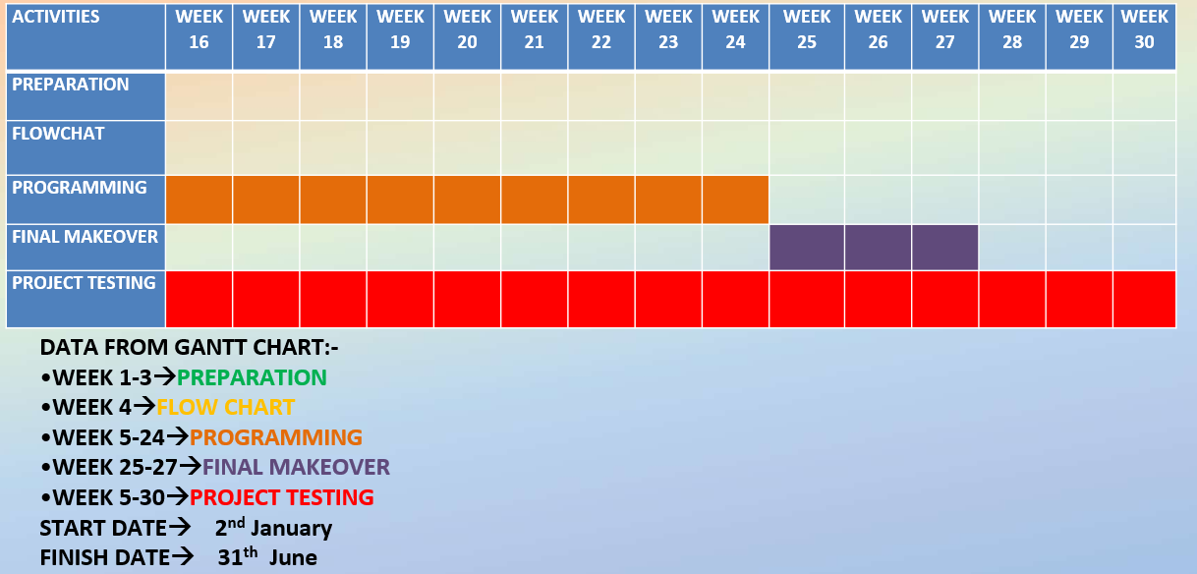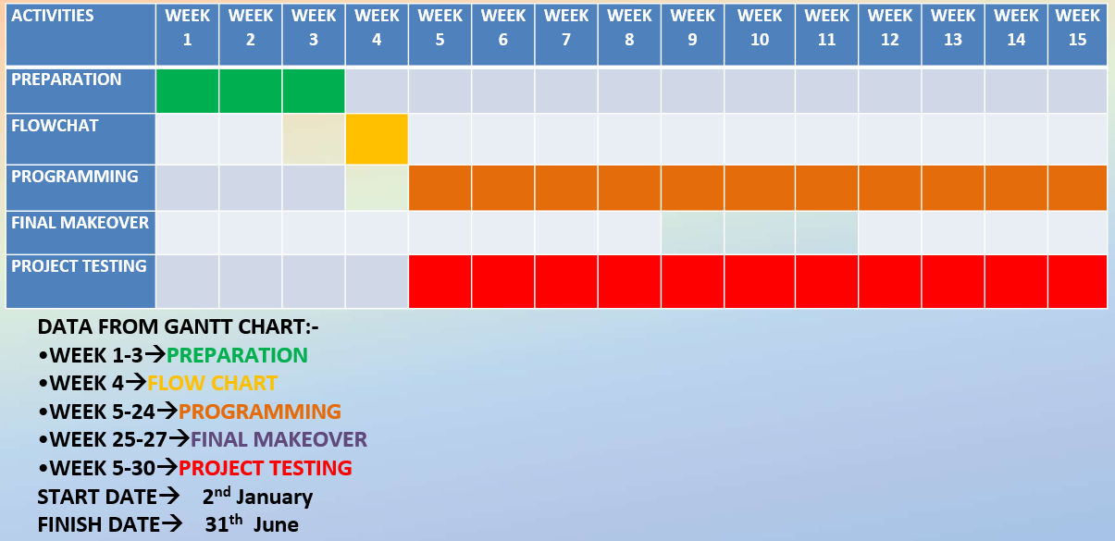

**DATA FROM GANTT CHART:-**

1. **WEEK 1-3**🡪**PREPARATION**
2. **WEEK 4🡪FLOW CHART**
3. **WEEK 5-24🡪PROGRAMMING**
4. **WEEK 25-27🡪FINAL MAKEOVER**
5. **WEEK 5-30🡪PROJECT TESTING**

**START DATE🡪 2nd January**

**FINISH DATE🡪 31th June**

**CHAPTER-5**

**“CODING”**

**“HTML , CSS , JAVASCRIPT”**

<!DOCTYPE html>

<html lang="en">

<head>

<meta charset="UTF-8">

<meta name="viewport" content="width=device-width, initial-scale=1.0">

<title>Vehicle Servicing System</title>

<link rel="icon" href="photo/Untitled-removebg-preview.png">

<style>

body {

font-family: Arial, sans-serif;

margin: 0;

padding: 0;

background-color: #f9f9f9;

color: #333;

}

.background-video {

position: fixed;

top: 0;

left: 0;

width: 100%;

height: 100%;

object-fit: cover;

z-index: -1;

}

.video-container {

display: none;

}

header {

/* position: sticky; */

top: 0;

display: flex;

justify-content: space-between;

align-items: center;

background-color: rgba(0, 0, 0, 0.5);

color: white;

padding: 1rem;

backdrop-filter: blur(2px);

transition: top 0.3s;

}

.hidden-header {

top: -100px;

}

.left-header {

display: flex;

align-items: center;

}

.left-header input[type="text"] {

padding: 8px;

border-radius: 4px;

border: none;

outline: none;

font-size: 14px;

}

.right-header {

display: flex;

gap: 15px;

}

.right-header a {

color: white;

text-decoration: none;

font-size: 14px;

padding: 8px 15px;

background: linear-gradient(145deg,rgb(94, 165, 209),rgb(162, 96, 198));

background-color: #005bb5;

border-radius: 4px;

}

.right-header a:hover {

background: linear-gradient(145deg,rgb(68, 152, 42),rgb(83, 165, 144));

}

.logo {

display: flex;

align-items: center;

}

.logo img {

width: 90px;

height: 90px;

margin-right: 10px;

}

.auth-buttons {

display: flex;

gap: 10px;

}

.auth-buttons button {

background-color: white;

color: #0073e6;

border: none;

padding: 10px 15px;

border-radius: 4px;

cursor: pointer;

font-size: 14px;

}

.auth-buttons button:hover {

background-color: #005bb5;

color: white;

}

h1 {

color: #0073e6;

}

section {

display: flex;

justify-content: space-between;

align-items: center;

margin: 2rem auto;

max-width: 800px;

padding: 1rem;

background-color: #fff;

border-radius: 8px;

box-shadow: 0 4px 6px rgba(0, 0, 0, 0.1);

backdrop-filter: blur(2px);

transition: top 0.3s;

}

.auto-typing {

font-size: 1.5rem;

font-weight: bold;

color:rgb(2, 15, 250);

}

.image-container img {

max-width: 100%;

height: auto;

border-radius: 8px;

}

@keyframes typing {

from { width: 0; }

to { width: 100%; }

}

.auto-typing span {

display: inline-block;

overflow: hidden;

white-space: nowrap;

border-right: 2px solid #0073e6;

animation: typing 4s steps(20) infinite alternate;

}

.scroll-section {

margin: 2rem auto;

max-width: 800px;

display: flex;

flex-wrap: wrap;

gap: 20px;

justify-content: center;

backdrop-filter: blur(2px);

transition: top 0.3s;

}

.scroll-item {

width: 200px;

height: 150px;

background-color: #0073e6;

color: white;

display: flex;

align-items: center;

justify-content: center;

font-size: 1.2rem;

border-radius: 8px;

opacity: 0;

transform: translateY(50px);

transition: all 0.5s ease-out;

}

.scroll-item.show {

opacity: 1;

transform: translateY(0);

}

.feedback-section {

margin: 2rem auto;

max-width: 800px;

padding: 1rem;

text-align: center;

background-color: #fff;

border-radius: 8px;

box-shadow: 0 4px 6px rgba(0, 0, 0, 0.1);

}

.feedback-container {

position: relative;

height: 150px;

overflow: hidden;

display: flex;

flex-direction: column;

align-items: center;

}

.feedback-item {

font-size: 1.2rem;

color: #333;

padding: 10px;

opacity: 0;

transform: translateY(50px);

animation: scrollFeedback 5s linear infinite;

}

@keyframes scrollFeedback {

0% { opacity: 1; transform: translateY(0); }

100% { opacity: 0; transform: translateY(-50px); }

}

.main-content {

display: flex;

margin-top: 20px;

}

#posts-container {

width: 75%;

}

.sidebar {

width: 25%;

padding: 20px;

background-color: #e9e9e9;

margin-left: 20px;

}

.sidebar h3 {

margin-bottom: 10px;

}

#addPostForm input, #addPostForm textarea {

width: 100%;

padding: 10px;

margin-bottom: 10px;

}

#addPostForm button {

padding: 10px 20px;

background-color: #333;

color: white;

border: none;

cursor: pointer;

}

footer {

background-color: #333;

color: #fff;

padding: 2rem 0;

font-size: 0.9rem;

backdrop-filter: blur(2px);

transition: top 0.3s;

}

.footer-container {

display: flex;

flex-wrap: wrap;

justify-content: space-around;

max-width: 1200px;

margin: 0 auto;

padding: 0 1rem;

}

.footer-section {

flex: 1 1 200px;

margin: 1rem;

}

.footer-section h3 {

border-bottom: 2px solid #0073e6;

padding-bottom: 0.5rem;

margin-bottom: 1rem;

}

.footer-section ul {

list-style: none;

padding: 0;

}

.footer-section ul li {

margin-bottom: 0.5rem;

}

.footer-section ul li a {

color: #fff;

text-decoration: none;

}

.footer-section ul li a:hover {

text-decoration: underline;

}

.social-icons a {

display: inline-block;

margin-right: 10px;

}

.social-icons img {

width: 24px;

height: 24px;

}

.footer-bottom {

text-align: center;

margin-top: 1rem;

border-top: 1px solid #444;

padding-top: 1rem;

}

.feedback-button {

position: fixed;

right: 20px;

bottom: 20px;

background: linear-gradient(145deg,rgb(94, 165, 209),rgb(162, 96, 198));

color: white;

border: none;

padding: 10px 20px;

border-radius: 50px;

cursor: pointer;

box-shadow: 0 4px 6px rgba(0, 0, 0, 0.2);

font-size: 14px;

z-index: 1000;

backdrop-filter: blur(2px);

transition: top 0.3s;

}

.feedback-button:hover {

background: linear-gradient(145deg,rgb(68, 152, 42),rgb(83, 165, 144));

}

/* .call-support {

position: fixed;

right: 20px;

bottom: 80px;

background-color: #0073e6;

color: white;

border: none;

padding: 10px 20px;

border-radius: 50px;

cursor: pointer;

box-shadow: 0 4px 6px rgba(0, 0, 0, 0.2);

font-size: 14px;

z-index: 1000;

display: flex;

align-items: center;

gap: 10px;

}

.call-support:hover {

background-color: #005bb5;

} */

.chatbot {

position: fixed;

bottom: 140px;

right: 20px;

background: linear-gradient(145deg,rgb(94, 165, 209),rgb(162, 96, 198));

color: white;

border: none;

border-radius: 50%;

width: 60px;

height: 60px;

display: flex;

align-items: center;

justify-content: center;

font-size: 24px;

cursor: pointer;

box-shadow: 0 4px 6px rgba(0, 0, 0, 0.2);

z-index: 1000;

}

.chatbot:hover {

background: linear-gradient(145deg,rgb(68, 152, 42),rgb(83, 165, 144));

}

.chatbot-popup {

position: fixed;

bottom: 200px;

right: 20px;

width: 300px;

height: 400px;

background-color: white;

border: 1px solid #ccc;

border-radius: 8px;

box-shadow: 0 4px 6px rgba(0, 0, 0, 0.2);

display: none;

flex-direction: column;

overflow: hidden;

z-index: 1000;

}

.chatbot-header {

background-color: #0073e6;

color: white;

padding: 10px;

text-align: center;

}

.chatbot-messages {

flex: 1;

padding: 10px;

overflow-y: auto;

}

.chatbot-input {

display: flex;

border-top: 1px solid #ccc;

}

.chatbot-input input {

flex: 1;

border: none;

padding: 10px;

outline: none;

}

.chatbot-input button {

background-color: #0073e6;

color: white;

border: none;

padding: 10px;

cursor: pointer;

}

.chatbot-input button:hover {

background-color: #005bb5;

}

.scroll-section {

margin: 2rem auto;

max-width: 800px;

display: flex;

flex-wrap: wrap;

gap: 20px;

justify-content: center;

backdrop-filter: blur(2px);

transition: top 0.3s;

}

.scroll-item {

width: 200px;

height: 150px;

cursor: pointer;

background-color: #0073e6;

color: white;

display: flex;

align-items: center;

justify-content: center;

font-size: 1.2rem;

border-radius: 8px;

opacity: 0;

transform: translateY(50px);

transition: all 0.5s ease-out;

overflow: hidden; /* Prevents images from overflowing */

}

.scroll-item.show {

opacity: 1;

transform: translateY(0);

}

.scroll-section img {

width: 100%;

height: 100%;

object-fit: cover; /* Ensures images fit well within the container */

border-radius: 8px; /* Optional: to round corners of images */

}

</style>

</head>

<body>

<video class="background-video" id="bgVideo" autoplay muted loop>

<source src="video/istockphoto-1680698591-640_adpp_is.mp4" type="video/mp4">

Your browser does not support HTML5 video.

</video>

<header>

<div class="logo">

<img src="photo/Blue_Gold_Minimalist_Car_Showroom_Logo-removebg-preview.png" alt="Vehicle Logo">

</div>

<div class="right-header">

<a href="signup.html">SignUp</a>

<a href="login.html">Login</a>

</div>

</header>

<section>

<div class="auto-typing">

<center>

<h2>Register your</h2>

<p><span id="typing">Car</span></p>

<h6>If you have any issue complent

here to raise your ticket </h6>

</center>

</div>

<div class="image-container">

<img src="photo/pngtree-auto-repair-vector-png-image_6888531.png" alt="Vehicle Servicing System">

</div>

</section>

<section class="scroll-section">

<div class="scroll-item">Photo 1</div>

<div class="scroll-item">Photo 2</div>

<div class="scroll-item"><img src="grp_image/WhatsApp Image 2025-02-17 at 10.00.06_534cfaf4.jpg" alt=""></div>

<div class="scroll-item"><img src="grp_image/WhatsApp Image 2025-02-17 at 10.00.05_c473f5d4.jpg" alt=""></div>

<div class="scroll-item"><img src="grp_image/WhatsApp Image 2025-02-17 at 10.00.05_fab3e083.jpg" alt=""></div>

<div class="scroll-item"><img src="grp_image/WhatsApp Image 2025-02-17 at 10.00.06_ebabe104.jpg" alt=""></div>

</section>

<button class="feedback-button" onclick="location.href='feedback.html'">Feedback</button>

<button class="chatbot" onclick="toggleChatbot()">💬</button>

<div class="chatbot-popup" id="chatbotPopup">

<div class="chatbot-header">Chat Support</div>

<div class="chatbot-messages" id="chatbotMessages"></div>

<div class="chatbot-input">

<input type="text" id="chatbotInput" placeholder="Type a message...">

<button onclick="sendMessage()">Send</button>

</div>

</div>

<script>

const chatbotPopup = document.getElementById("chatbotPopup");

const chatbotMessages = document.getElementById("chatbotMessages");

const chatbotInput = document.getElementById("chatbotInput");

function toggleChatbot() {

chatbotPopup.style.display = chatbotPopup.style.display === "flex" ? "none" : "flex";

}

function sendMessage() {

const message = chatbotInput.value.trim();

if (message) {

const userMessage = document.createElement("div");

userMessage.textContent = message;

userMessage.style.marginBottom = "10px";

userMessage.style.textAlign = "right";

chatbotMessages.appendChild(userMessage);

chatbotInput.value = "";

setTimeout(() => {

const botMessage = document.createElement("div");

botMessage.textContent = "Hello ! Thank you for choosing for.";

botMessage.style.marginBottom = "10px";

botMessage.style.textAlign = "left";

chatbotMessages.appendChild(botMessage);

chatbotMessages.scrollTop = chatbotMessages.scrollHeight;

}, 1000);

}

}

</script>

<script>

const scrollItems = document.querySelectorAll(".scroll-item");

const scrollObserver = new IntersectionObserver((entries) => {

entries.forEach(entry => {

if (entry.isIntersecting) {

entry.target.classList.add("show");

} else {

entry.target.classList.remove("show");

}

});

}, { threshold: 0.5 });

scrollItems.forEach(item => scrollObserver.observe(item));

const words = ["HERO","HONDA","MAHINDRA","SUZUKI","SKODA","HONDA","KIA","HYUNDAI","BMW","JAGUAR","MERCIDIES","LAMBORGINI","TOYOTA"];

let i = 0;

const typingElement = document.getElementById("typing");

function autoType() {

typingElement.textContent = words[i];

i = (i + 1) % words.length;

}

setInterval(autoType, 2000);

</script>

<section class="feedback-section">

<h2>Customer Feedback</h2>

<div class="feedback-container">

<div class="feedback-item">Fetching feedback...</div>

</div>

</section>

<script>

async function fetchFeedback() {

const feedbackContainer = document.querySelector('.feedback-container');

feedbackContainer.innerHTML = ''; // Clear placeholder

try {

const response = await fetch('php/feedbackcall.php'); // Fetch feedback

const feedbackData = await response.json();

if (!Array.isArray(feedbackData)) {

throw new Error('Invalid response format');

}

feedbackData.forEach(feedback => {

const feedbackItem = document.createElement('div');

feedbackItem.classList.add('feedback-item');

feedbackItem.textContent = feedback; // Display feedback message

feedbackContainer.appendChild(feedbackItem);

});

// Auto-scroll effect for feedback

let index = 0;

setInterval(() => {

const items = document.querySelectorAll('.feedback-item');

items.forEach((item, i) => {

item.style.opacity = i === index ? '1' : '0';

item.style.transform = i === index ? 'translateY(0)' : 'translateY(50px)';

});

index = (index + 1) % items.length;

}, 3000);

} catch (error) {

feedbackContainer.textContent = 'Failed to load feedback.';

console.error('Error fetching feedback:', error);

}

}

// Fetch feedback on page load

document.addEventListener("DOMContentLoaded", fetchFeedback);

</script>

<!-- blog section -->

<!-- footer section -->

<footer>

<div class="footer-container">

<div class="footer-section">

<h3>About Us</h3>

<p>Providing top-notch vehicle servicing solutions with a focus on customer satisfaction and quality.</p>

</div>

<div class="footer-section">

<h3>Helping</h3>

<ul>

<li>In this platform we add local gaurage owner and help them to take their bussiness online</li>

</ul>

</div>

<div class="footer-section">

<h3>Contact Us</h3>

<p>Electronic City Phase 1<br>Banglore, India 560100</p>

<p>Email: merigaddi0008@gmail.com</p>

<p>Phone: +91 8340300338</p>

</div>

<div class="footer-section">

<h3>Follow Us</h3>

<div class="social-icons">

<a href="https://www.facebook.com/profile.php?id=61573648584570"><img src="facebook-icon.png" alt="Facebook"></a>

<a href="https://x.com/merigaddi0008"><img src="twitter-icon.png" alt="Twitter"></a>

<a href="https://www.threads.net/@merigaddi0008"><img src="twitter-icon.png" alt="Thread"></a>

<a href="https://www.instagram.com/merigaddi0008?igsh=MXg0OWhjc3ExMThzbw=="><img src="instagram-icon.png" alt="Instagram"></a>

</div>

</div>

<div class="footer-map">

<!-- Google Maps Embed -->

<iframe

src="https://www.google.com/maps/embed?pb=!1m14!1m8!1m3!1d2750.609666581145!2d77.66778381890838!3d12.846538587509404!3m2!1i1024!2i768!4f13.1!3m3!1m2!1s0x3bae149285b279d1%3A0x8d1750ebbe9a9c0a!2sNTTF%20Electronics%20%26%20IT!5e0!3m2!1sen!2sin!4v1744014544030!5m2!1sen!2sin"

width="200" height="150" style="border:0;"

allowfullscreen=""

loading="lazy"

referrerpolicy="no-referrer-when-downgrade">

</iframe>"

</div>

</div>

<div class="footer-bottom">

<p>&copy; 2025 Vehicle Servicing System. All rights reserved.</p>

</div>

</footer>

</body>

</html>

<?php

session_start();

if (!isset($_SESSION['email'])) {

header("Location: login.php");

exit();

}

$servername = "localhost";

$username = "root";

$password = "";

$dbname = "final"; // Replace with your actual database name

// Create connection

$conn = new mysqli($servername, $username, $password, $dbname);

// Check connection

if ($conn->connect_error) {

die("Connection failed: " . $conn->connect_error);

}

// SQL query to fetch posts

$sql = "SELECT NAME,EMAIL,IMAGE,FEEDBACK FROM feedback";

$result = $conn->query($sql);

?>

<!DOCTYPE html>

<html lang="en">

<head>

<meta charset="UTF-8">

<meta name="viewport" content="width=device-width, initial-scale=1.0">

<title>Vehicle Servicing System</title>

<link rel="icon" href="photo/Untitled-removebg-preview.png">

<link rel="icon" href="photo/Untitled-removebg-preview.png">

<link rel="stylesheet" href="https://cdnjs.cloudflare.com/ajax/libs/font-awesome/6.4.0/css/all.min.css">

<link href="https://fonts.googleapis.com/css2?family=Poppins:wght@300;400;500;600;700&display=swap" rel="stylesheet">

<!-- Font Awesome for icons -->

<link rel="stylesheet" href="https://cdnjs.cloudflare.com/ajax/libs/font-awesome/6.4.0/css/all.min.css">

<style>

body {

font-family: Arial, sans-serif;

margin: 0;

padding: 0;

background-color: #f9f9f9;

color: #333;

}

.background-video {

position: fixed;

top: 0;

left: 0;

width: 100%;

height: 100%;

object-fit: cover;

z-index: -1;

}

.video-container {

display: none;

}

:root {

--primary: #4361ee;

--primary-light: #4895ef;

--secondary: #3f37c9;

--success: #4cc9f0;

--success-dark: #4361ee;

--danger: #f72585;

--dark: #212529;

--light: #f8f9fa;

--border: #e9ecef;

}

* {

margin: 0;

padding: 0;

box-sizing: border-box;

}

body {

font-family: 'Poppins', Arial, sans-serif;

margin: 0;

padding: 0;

background-color: #f0f2f5;

color: #333;

overflow-x: hidden;

}

.background-video {

position: fixed;

top: 0;

left: 0;

width: 100%;

height: 100%;

object-fit: cover;

z-index: -1;

opacity: 0.5;

}

.container {

max-width: 1200px;

margin: 30px auto;

padding: 0 20px;

}

/* Header Styles */

header {

background: linear-gradient(135deg, rgba(24, 24, 27, 0.9), rgba(39, 39, 42, 0.8));

color: white;

padding: 1rem;

position: fixed; /* Changed from sticky to fixed */

top: 0;

width: 100%; /* Ensure full width */

z-index: 1000;

box-shadow: 0 4px 12px rgba(0, 0, 0, 0.1);

backdrop-filter: blur(10px);

transition: transform 0.3s ease; /* Added transition for smooth hide/show */

}

/* Class to hide header when scrolling up */

header.hide {

transform: translateY(-100%);

}

/* Add top padding to body to compensate for fixed header */

body {

padding-top: 90px; /* Adjust this value based on your header height */

}

.header-container {

max-width: 1200px;

margin: 0 auto;

display: flex;

justify-content: space-between;

align-items: center;

}

.logo {

display: flex;

align-items: center;

}

.logo img {

width: 70px;

height: 70px;

margin-right: 10px;

transition: transform 0.3s ease;

}

.logo img:hover {

transform: scale(1.05);

}

.right-header {

display: flex;

gap: 15px;

align-items: center;

}

.right-header a {

color: white;

text-decoration: none;

font-size: 14px;

padding: 8px 16px;

border-radius: 6px;

transition: all 0.3s ease;

position: relative;

overflow: hidden;

}

.right-header a::before {

content: '';

position: absolute;

top: 0;

left: -100%;

width: 100%;

height: 100%;

background: rgba(255, 255, 255, 0.1);

transition: all 0.3s ease;

}

.right-header a:hover::before {

left: 0;

}

.nav-link {

background: transparent;

border: 1px solid rgba(255, 255, 255, 0.2);

}

.nav-link:hover {

background: rgba(255, 255, 255, 0.1);

transform: translateY(-2px);

}

.accent-link {

background: linear-gradient(135deg, var(--primary), var(--secondary));

box-shadow: 0 4px 12px rgba(67, 97, 238, 0.2);

}

.accent-link:hover {

background: linear-gradient(135deg, var(--secondary), var(--primary));

transform: translateY(-2px);

box-shadow: 0 6px 16px rgba(67, 97, 238, 0.3);

}

/* User Menu Styles */

.user-menu {

position: relative;

display: inline-block;

}

.user-email {

color: white;

text-decoration: none;

font-size: 14px;

padding: 8px 16px;

border-radius: 6px;

background: linear-gradient(135deg, var(--primary), var(--secondary));

cursor: pointer;

display: flex;

align-items: center;

gap: 6px;

transition: all 0.3s ease;

}

.user-email:hover {

transform: translateY(-2px);

box-shadow: 0 6px 16px rgba(67, 97, 238, 0.3);

}

.user-icon {

font-size: 16px;

}

.logout-menu {

display: none;

position: absolute;

top: 120%;

right: 0;

background: white;

border-radius: 8px;

width: 180px;

box-shadow: 0 8px 24px rgba(0, 0, 0, 0.15);

z-index: 1000;

overflow: hidden;

animation: slideDown 0.3s ease forwards;

}

@keyframes slideDown {

from {

opacity: 0;

transform: translateY(-10px);

}

to {

opacity: 1;

transform: translateY(0);

}

}

.logout-menu-item {

display: flex;

align-items: center;

gap: 10px;

padding: 12px 16px;

color: var(--dark);

text-decoration: none;

font-size: 14px;

transition: all 0.9s ease;

border-bottom: 1px solid var(--border);

}

.logout-menu-item:last-child {

border-bottom: none;

color:#18181b;

}

.logout-menu-item i {

font-size: 16px;

width: 20px;

text-align: center;

color:#18181b;

}

.logout-menu-item:hover {

background-color:rgb(245, 245, 245);

padding-left: 20px;

}

.logout-menu-item.danger {

color: white;

}

.logout-menu-item.danger:hover {

background-color: rgba(247, 37, 133, 0.05);

}

/* Show logout when hovering over email */

.user-menu:hover .logout-menu {

display: block;

}

/* Page Title Styles */

.page-header {

text-align: center;

margin: 40px 0 30px;

position: relative;

}

.page-title {

font-size: 32px;

font-weight: 600;

color: var(--dark);

margin-bottom: 10px;

position: relative;

display: inline-block;

}

.page-title::after {

content: '';

position: absolute;

bottom: -8px;

left: 50%;

transform: translateX(-50%);

width: 80px;

height: 4px;

background: linear-gradient(to right, var(--primary), var(--secondary));

border-radius: 2px;

}

.subtitle {

color: #6c757d;

font-size: 16px;

max-width: 600px;

margin: 0 auto;

}

/* Orders Table Styles */

.data-container {

background-color: white;

border-radius: 12px;

box-shadow: 0 8px 30px rgba(0, 0, 0, 0.08);

padding: 30px;

margin-bottom: 40px;

overflow: hidden;

position: relative;

}

.data-container::before {

content: '';

position: absolute;

top: 0;

left: 0;

width: 100%;

height: 5px;

background: linear-gradient(to right, var(--primary), var(--secondary));

}

section {

display: flex;

justify-content: space-between;

align-items: center;

margin: 2rem auto;

max-width: 800px;

padding: 1rem;

background-color: #fff;

border-radius: 8px;

box-shadow: 0 4px 6px rgba(0, 0, 0, 0.1);

backdrop-filter: blur(2px);

transition: top 0.3s;

}

.auto-typing {

font-size: 1.5rem;

font-weight: bold;

color:blue;

/* background: linear-gradient(145deg,rgb(68, 152, 42),rgb(83, 165, 144)); */

}

.image-container img {

max-width: 100%;

height: auto;

border-radius: 8px;

}

@keyframes typing {

from { width: 0; }

to { width: 100%; }

}

.auto-typing span {

display: inline-block;

overflow: hidden;

white-space: nowrap;

border-right: 2px solid #0073e6;

animation: typing 4s steps(20) infinite alternate;

}

.scroll-section {

margin: 2rem auto;

max-width: 800px;

display: flex;

flex-wrap: wrap;

gap: 20px;

justify-content: center;

backdrop-filter: blur(2px);

transition: top 0.3s;

}

.scroll-item {

width: 200px;

height: 150px;

background-color:rgb(32, 140, 241);

color: white;

display: flex;

align-items: center;

justify-content: center;

font-size: 1.2rem;

border-radius: 8px;

opacity: 0;

transform: translateY(50px);

transition: all 0.5s ease-out;

}

.scroll-item img {

width: 150px; /* Set the desired width for the logos */

height: 100px; /* Set the desired height for the logos */

object-fit: contain; /* Ensure the aspect ratio is maintained */

border-radius: 8px;

}

.scroll-item.show {

opacity: 1;

transform: translateY(0);

}

/* IMPROVED FEEDBACK SECTION STYLING */

.feedback-section {

margin: 2rem auto;

max-width: 800px;

padding: 1.5rem;

text-align: center;

background-color: #fff;

border-radius: 12px;

box-shadow: 0 6px 18px rgba(0, 0, 0, 0.12);

}

.feedback-section h2 {

color: #0073e6;

margin-bottom: 1.5rem;

font-size: 28px;

position: relative;

display: inline-block;

}

.feedback-section h2:after {

content: '';

position: absolute;

width: 50%;

height: 3px;

background: linear-gradient(90deg, #0073e6, transparent);

left: 25%;

bottom: -10px;

}

.feedback-container {

display: grid;

grid-template-columns: repeat(auto-fill, minmax(300px, 1fr));

gap: 20px;

max-height: 500px;

overflow-y: auto;

padding: 10px;

scrollbar-width: thin;

scrollbar-color: #0073e6 #f0f0f0;

}

.feedback-container::-webkit-scrollbar {

width: 8px;

}

.feedback-container::-webkit-scrollbar-track {

background: #f0f0f0;

border-radius: 10px;

}

.feedback-container::-webkit-scrollbar-thumb {

background-color: #0073e6;

border-radius: 10px;

}

.feedback-item {

background-color: #f9f9f9;

border-radius: 10px;

padding: 20px;

box-shadow: 0 4px 8px rgba(0, 0, 0, 0.08);

text-align: left;

transition: all 0.3s ease;

border-left: 4px solid #0073e6;

animation: fadeIn 0.5s ease-in;

position: relative;

overflow: hidden;

}

.feedback-item:before {

content: '"';

position: absolute;

top: 10px;

left: 10px;

font-size: 60px;

color: rgba(0, 115, 230, 0.1);

font-family: Georgia, serif;

line-height: 1;

}

.feedback-item:hover {

transform: translateY(-5px);

box-shadow: 0 8px 16px rgba(0, 115, 230, 0.15);

}

.feedback-item.highlight {

background-color: #e6f3ff;

border-left: 4px solid #0073e6;

transform: scale(1.02);

}

.feedback-author {

display: flex;

align-items: center;

margin-bottom: 15px;

padding-left: 15px;

}

.feedback-author img {

width: 50px;

height: 50px;

border-radius: 50%;

object-fit: cover;

margin-right: 15px;

border: 3px solid #0073e6;

box-shadow: 0 3px 6px rgba(0, 0, 0, 0.1);

}

.feedback-author span {

font-weight: bold;

color: #0073e6;

font-size: 1.1rem;

}

.feedback-item p {

margin: 0;

color: #555;

font-size: 0.95rem;

line-height: 1.6;

padding-left: 15px;

position: relative;

z-index: 1;

}

@keyframes fadeIn {

from { opacity: 0; transform: translateY(20px); }

to { opacity: 1; transform: translateY(0); }

}

footer {

background-color: #333;

color: #fff;

padding: 2rem 0;

font-size: 0.9rem;

backdrop-filter: blur(2px);

transition: top 0.3s;

}

.footer-container {

display: flex;

flex-wrap: wrap;

justify-content: space-around;

max-width: 1200px;

margin: 0 auto;

padding: 0 1rem;

}

.footer-section {

flex: 1 1 200px;

margin: 1rem;

}

<style>

.carousel-container {

overflow: hidden;

width: 100%;

max-width: 800px;

margin: 0 auto;

position: relative;

border-radius: 12px;

}

.carousel-track {

display: flex;

width: max-content;

animation: scroll 25s linear infinite;

}

.carousel-item {

flex: 0 0 auto;

width: 300px;

margin: 20px;

background: #f4f4f4;

border-radius: 10px;

padding: 20px;

text-align: center;

box-shadow: 0 4px 8px rgba(0,0,0,0.1);

}

.carousel-item img {

width: 80px;

height: 80px;

object-fit: cover;

border-radius: 50%;

margin-bottom: 10px;

}

@keyframes scroll {

0% {

transform: translateX(0);

}

100% {

transform: translateX(-100%);

}

}

.footer-section h3 {

border-bottom: 2px solid #0073e6;

padding-bottom: 0.5rem;

margin-bottom: 1rem;

}

.footer-section ul {

list-style: none;

padding: 0;

}

.footer-section ul li {

margin-bottom: 0.5rem;

}

.footer-section ul li a {

color: #fff;

text-decoration: none;

}

.footer-section ul li a:hover {

text-decoration: underline;

}

.social-icons a {

display: inline-block;

margin-right: 10px;

}

.social-icons img {

width: 24px;

height: 24px;

}

.footer-bottom {

text-align: center;

margin-top: 1rem;

border-top: 1px solid #444;

padding-top: 1rem;

}

.feedback-button {

position: fixed;

right: 20px;

bottom: 20px;

background: linear-gradient(145deg,rgb(94, 165, 209),rgb(162, 96, 198));

color: white;

border: none;

padding: 10px 20px;

border-radius: 50px;

cursor: pointer;

box-shadow: 0 4px 6px rgba(0, 0, 0, 0.2);

font-size: 14px;

z-index: 1000;

backdrop-filter: blur(2px);

transition: top 0.3s;

}

.feedback-button:hover {

background: linear-gradient(145deg,rgb(68, 152, 42),rgb(83, 165, 144));

}

/* .call-support {

position: fixed;

right: 20px;

bottom: 80px;

background-color: #0073e6;

color: white;

border: none;

padding: 10px 20px;

border-radius: 50px;

cursor: pointer;

box-shadow: 0 4px 6px rgba(0, 0, 0, 0.2);

font-size: 14px;

z-index: 1000;

display: flex;

align-items: center;

gap: 10px;

}

.call-support:hover {

background-color: #005bb5;

} */

.chatbot {

position: fixed;

bottom: 140px;

right: 20px;

background: linear-gradient(145deg,rgb(94, 165, 209),rgb(162, 96, 198));

color: white;

border: none;

border-radius: 50%;

width: 60px;

height: 60px;

display: flex;

align-items: center;

justify-content: center;

font-size: 24px;

cursor: pointer;

box-shadow: 0 4px 6px rgba(0, 0, 0, 0.2);

z-index: 1000;

}

.chatbot:hover {

background: linear-gradient(145deg,rgb(68, 152, 42),rgb(83, 165, 144));

}

.chatbot-popup {

position: fixed;

bottom: 200px;

right: 20px;

width: 300px;

height: 400px;

background-color: white;

border: 1px solid #ccc;

border-radius: 8px;

box-shadow: 0 4px 6px rgba(0, 0, 0, 0.2);

display: none;

flex-direction: column;

overflow: hidden;

z-index: 1000;

}

.chatbot-header {

background-color: #0073e6;

color: white;

padding: 10px;

text-align: center;

}

.chatbot-messages {

flex: 1;

padding: 10px;

overflow-y: auto;

}

.chatbot-input {

display: flex;

border-top: 1px solid #ccc;

}

.chatbot-input input {

flex: 1;

border: none;

padding: 10px;

outline: none;

}

.chatbot-input button {

background-color: #0073e6;

color: white;

border: none;

padding: 10px;

cursor: pointer;

}

.chatbot-input button:hover {

background-color: #005bb5;

}

.user-menu {

position: relative;

display: inline-block;

}

.user-email {

color: white;

text-decoration: none;

font-size: 14px;

padding: 8px 15px;

background: linear-gradient(145deg, rgb(94, 165, 209), rgb(162, 96, 198));

border-radius: 4px;

cursor: pointer;

display: inline-block;

transition: background 0.3s ease;

}

.user-email:hover {

background: linear-gradient(145deg, rgb(68, 152, 42), rgb(83, 165, 144));

}

.logout-menu {

display: none;

position: absolute;

top: 100%;

left: 0;

background-color: rgba(0, 0, 0, 0.8);

border-radius: 4px;

padding: 5px 0;

min-width: 100px;

text-align: center;

box-shadow: 0 4px 6px rgba(0, 0, 0, 0.2);

}

.logout-menu a {

color: white;

text-decoration: none;

padding: 8px 15px;

display: block;

background: linear-gradient(145deg, rgb(255, 94, 94), rgb(198, 68, 68));

border-radius: 4px;

}

.logout-menu a:hover {

background: linear-gradient(145deg, rgb(165, 42, 42), rgb(144, 68, 68));

}

/* Show logout when hovering over email */

.user-menu:hover .logout-menu {

display: block;

}

</style>

</head>

<c>

<video class="background-video" id="bgVideo" autoplay muted loop>

<source src="video/istockphoto-1680698591-640_adpp_is.mp4" type="video/mp4">

Your browser does not support HTML5 video.

</video>

<header id="site-header">

<div class="header-container">

<div class="logo">

<img src="photo/Blue_Gold_Minimalist_Car_Showroom_Logo-removebg-preview.png" alt="Vehicle Logo">

</div>

<div class="right-header">

<a href="home.php" class="nav-link"><i class="fas fa-home"></i> Home</a>

<a href="php/blog.php" class="nav-link"><i class="fas fa-blog"></i> Blog</a>

<a href="appointment.php" class="accent-link"><i class="fas fa-calendar-check"></i> Book Appointment</a>

<div class="user-menu">

<div class="user-email">

<i class="fas fa-user-circle user-icon"></i>

<?php echo htmlspecialchars($_SESSION['email']); ?>

<i class="fas fa-chevron-down" style="font-size: 12px;"></i>

</div>

<div class="logout-menu">

<a href="php/orderdetails.php" class="logout-menu-item">

<i class="fas fa-clipboard-list"></i> My Orders

</a>

<a href="php/appointmentdetails.php" class="logout-menu-item">

<i class="fas fa-clipboard-list"></i> Appointment Details

</a>

<a href="logout.php" class="logout-menu-item danger">

<i class="fas fa-sign-out-alt"></i> Logout

</a>

</div>

</div>

</div>

</div>

</header>

<section>

<div class="auto-typing">

<center>

<h2>Register your</h2>

<p><span id="typing">Car</span></p>

<h6>If you have any issue complent

here to raise your ticket </h6>

</center>

</div>

<div class="image-container">

<img src="photo/pngtree-auto-repair-vector-png-image_6888531.png" alt="Vehicle Servicing System">

</div>

</section>

<center><h2>Order Sphere here</h2></center>

<section class="scroll-section">

<div class="scroll-item"><a href="audirequest.php"><img src="servicelogo/audi.png" alt=""></a></div>

<div class="scroll-item"><a href="hondarequest.php"><img src="servicelogo/Honda.png" alt=""></a></div>

<div class="scroll-item"><a href="bmwrequest.php"><img src="servicelogo/bmw.png" alt=""></a></div>

<div class="scroll-item"><a href="fordrequest.php"><img src="servicelogo/ford.png" alt=""></a></div>

<div class="scroll-item"><a href="hundayrequest.php"><img src="servicelogo/hyundai.png" alt=""></a></div>

<div class="scroll-item"><a href="kiarequest.php"><img src="servicelogo/Kia.png" alt=""></a></div>

<div class="scroll-item"><a href="suzukirequest.php"><img src="servicelogo/suzuki.png" alt=""></a></div>

<div class="scroll-item"><a href="mahendrarequest.php"><img src="servicelogo/mahindra.png" alt=""></a></div>

<div class="scroll-item"><a href="mercidiserequest.php"><img src="servicelogo/mercedes.png" alt=""></a></div>

<div class="scroll-item"><a href="mgrequest.php"><img src="servicelogo/MG.png" alt=""></a></div>

<div class="scroll-item"><a href="nisanrequest.php"><img src="servicelogo/nissan.png" alt=""></a></div>

<div class="scroll-item"><a href="tatarequest.php"><img src="servicelogo/tata.png" alt=""></a></div>

<div class="scroll-item"><a href="tvsrequest.php"><img src="servicelogo/tvs.png" alt=""></a></div>

<div class="scroll-item"><a href="tyotarequest.php"><img src="servicelogo/toyota.png" alt=""></a></div>

<div class="scroll-item"><a href="herorequest.php"><img src="servicelogo/hero.png" alt=""></a></div>

</section>

<button class="feedback-button" onclick="location.href='feedbackhome.html'">Feedback</button>

<!-- <button class="chatbot" onclick="toggleChatbot()">💬</button>

<div class="chatbot-popup" id="chatbotPopup">

<div class="chatbot-header">Chat Support</div>

<div class="chatbot-messages" id="chatbotMessages"></div>

<div class="chatbot-input">

<input type="text" id="chatbotInput" placeholder="Type a message...">

<button onclick="sendMessage()">Send</button>

</div>

</div> -->

<script>

const chatbotPopup = document.getElementById("chatbotPopup");

const chatbotMessages = document.getElementById("chatbotMessages");

const chatbotInput = document.getElementById("chatbotInput");

function toggleChatbot() {

chatbotPopup.style.display = chatbotPopup.style.display === "flex" ? "none" : "flex";

}

function sendMessage() {

const message = chatbotInput.value.trim();

if (message) {

const userMessage = document.createElement("div");

userMessage.textContent = message;

userMessage.style.marginBottom = "10px";

userMessage.style.textAlign = "right";

chatbotMessages.appendChild(userMessage);

chatbotInput.value = "";

setTimeout(() => {

const botMessage = document.createElement("div");

botMessage.textContent = "Hello ! Thank you for choosing for.";

botMessage.style.marginBottom = "10px";

botMessage.style.textAlign = "left";

chatbotMessages.appendChild(botMessage);

chatbotMessages.scrollTop = chatbotMessages.scrollHeight;

}, 1000);

}

}

// Add scroll direction detection

let lastScrollTop = 0;

const header = document.getElementById('site-header');

window.addEventListener('scroll', function() {

let scrollTop = window.pageYOffset || document.documentElement.scrollTop;

// Make sure we've scrolled at least a certain amount to avoid flickering

if (Math.abs(lastScrollTop - scrollTop) <= 5)

return;

// If scrolling down, hide header

// If scrolling up or at the top of the page, show header

if (scrollTop > lastScrollTop && scrollTop > header.offsetHeight) {

// Scrolling down

header.classList.add('hide');

} else {

// Scrolling up or at top

header.classList.remove('hide');

}

lastScrollTop = scrollTop;

}, false);

</script>

<script>

const scrollItems = document.querySelectorAll(".scroll-item");

const scrollObserver = new IntersectionObserver((entries) => {

entries.forEach(entry => {

if (entry.isIntersecting) {

entry.target.classList.add("show");

} else {

entry.target.classList.remove("show");

}

});

}, { threshold: 0.5 });

scrollItems.forEach(item => scrollObserver.observe(item));

const words = ["HERO","HONDA","MAHINDRA","SUZUKI","SKODA","HONDA","KIA","HYUNDAI","BMW","JAGUAR","MERCIDIES","LAMBORGINI","TOYOTA"];

let i = 0;

const typingElement = document.getElementById("typing");

function autoType() {

typingElement.textContent = words[i];

i = (i + 1) % words.length;

}

setInterval(autoType, 2000);

</script>

<<section class="feedback-section">

<h2 style="text-align:center;">What Our Customers<br> <strong>Say!</strong></h2>

<div class="feedback-container">

<?php

$con = mysqli_connect('localhost', 'root', '', 'final');

$result = mysqli_query($con, "SELECT * FROM feedback ORDER BY id DESC");

if ($result && $result->num_rows > 0) {

while ($row = $result->fetch_assoc()) {

echo '<div class="feedback-item">';

echo '<div class="feedback-author">';

$imagePath = !empty($row['IMAGE']) ? 'php/uploads/' . htmlspecialchars($row['IMAGE']) : 'photo/user-default.png';

echo '<img src="' . $imagePath . '" alt="User" width="100" height="100" style="object-fit: cover; border-radius: 50%;">';

echo '<span>' . htmlspecialchars($row['NAME']) . '</span>';

echo '</div>';

echo '<p>' . htmlspecialchars($row['FEEDBACK']) . '</p>';

echo '</div>';

}

} else {

echo '<p>No feedback available yet. Be the first to share your experience!</p>';

}

?>

</div>

</section>

<script>

// This script handles the animation of feedback items

document.addEventListener("DOMContentLoaded", function() {

const feedbackItems = document.querySelectorAll('.feedback-item');

// Add animation delay to each feedback item for a staggered effect

feedbackItems.forEach((item, index) => {

item.style.animationDelay = `${index * 0.2}s`;

});

// Optional: Add automatic cycling of feedback items if there are many

if (feedbackItems.length > 3) {

let currentIndex = 0;

setInterval(() => {

feedbackItems.forEach(item => item.classList.remove('highlight'));

feedbackItems[currentIndex].classList.add('highlight');

// Auto-scroll to the highlighted item

feedbackItems[currentIndex].scrollIntoView({ behavior: 'smooth', block: 'center' });

currentIndex = (currentIndex + 1) % feedbackItems.length;

}, 5000);

}

});

</script>

<!-- footer section -->

<footer>

<div class="footer-container">

<div class="footer-section">

<h3>About Us</h3>

<p>Providing top-notch vehicle servicing solutions with a focus on customer satisfaction and quality.</p>

</div>

<div class="footer-section">

<h3>Helping</h3>

<ul>

<li>In this platform we add local gaurage owner and help them to take their bussiness online</li>

</ul>

</div>

<div class="footer-section">

<h3>Contact Us</h3>

<p>Electronic City Phase 1<br>Banglore, India 560100</p>

<p>Email: merigaddi0008@gmail.com</p>

<p>Phone: +91 8340300338</p>

</div>

<div class="footer-section">

<h3>Follow Us</h3>

<div class="social-icons">

<a href="https://www.facebook.com/profile.php?id=61573648584570" class="facebook"><i class="fab fa-facebook-f"></i></a>

<a href="https://x.com/merigaddi0008" class="twitter"><i class="fab fa-twitter"></i></a>

<a href="https://www.threads.net/@merigaddi0008" class="threads"><i class="fab fa-threads"></i></a>

<a href="https://www.instagram.com/merigaddi0008?igsh=MXg0OWhjc3ExMThzbw==" class="instagram"><i class="fab fa-instagram"></i></a>

</div>

</div>

</div>

<div class="footer-bottom">

<p>&copy; 2025 Vehicle Servicing System. All rights reserved.</p>

</div>

</footer>

</div>

</body>

</html>

**PHP CODE**

<?php

// Start the session to track the user after successful login

session_start();

// Include database connection file (assuming you've created this)

//require_once 'signup.php';

// Check if form is submitted

if ($_SERVER["REQUEST_METHOD"] == "POST") {

// Get form inputs

$email = $_POST['username'];

$pass = $_POST['password'];

// Check if fields are not empty

if (!empty($email) && !empty($pass)) {

// Create a prepared statement to check for the user in the database

$sql = "SELECT Mail,Password FROM user WHERE Mail='$email'";

$conn = mysqli_connect('localhost','root','','final');

// $stmt = $conn->prepare($sql);

$re=mysqli_query($conn,$sql);

// $stmt->bind_param("s", $email);

// $stmt->execute();

// $stmt->store_result();

// Check if the user exists

if ($re->num_rows > 0) {

// Bind the result to variables

// $stmt->bind_result($db_Mail, $db_Password);

// $stmt->fetch();

$db_data= mysqli_fetch_array($re,MYSQLI_ASSOC);

$db_Password = $db_data['Password'];

$db_Mail = $db_data['Mail'];

// Verify the password

if($pass == $db_Password) {

//echo "hello";

// Password is correct, start a session and redirect

$_SESSION['email'] = $db_Mail;

$_SESSION['password'] = $db_Password;

// print_r($_SESSION['email']);

header('refresh:1; url=http://localhost/final year/home.php'); // Redirect to a dashboard or home page

exit();

} else {

// Invalid password

$error = "Incorrect password!";

header('refresh:0; url=http://localhost/final year/error.html');

}

} else {

// No user found with that email

$error = "No account found with that email.";

header('refresh:0; url=http://localhost/final year/error.html');

}

} else {

$error = "Please fill in both fields.";

}

}

$conn->close();

?>

<?php

$servername = "localhost";

$username = "root";

$password = "";

$dbname = "final";

$conn = new mysqli($servername, $username, $password, $dbname);

// Check connection

if ($conn->connect_error) {

die("Connection failed: " . $conn->connect_error);

}

if ($_SERVER['REQUEST_METHOD'] === 'POST' && isset($_POST['attendance'])) {

$attendance = $_POST['attendance'];

$date = $_POST['date'];

foreach ($attendance as $email => $status) {

if (!empty($status)) {

// Check if record already exists

$checkStmt = $conn->prepare("SELECT id FROM attendance WHERE email = ? AND date = ?");

$checkStmt->bind_param("ss", $email, $date);

$checkStmt->execute();

$checkStmt->store_result();

if ($checkStmt->num_rows == 0) {

// Insert attendance record only if not exists

$stmt = $conn->prepare("INSERT INTO attendance (email, date, status) VALUES (?, ?, ?)");

$stmt->bind_param("sss", $email, $date, $status);

$stmt->execute();

}

$checkStmt->close();

}

}

echo "<script>alert('Attendance saved for $date.'); window.location.href='adminindex.php';</script>";

} else {

echo "No attendance data submitted.";

}

?>

<?php

session_start();

if ($_SERVER["REQUEST_METHOD"] == "POST") {

$email = $_POST['email'];

$password = $_POST['password'];

if ($email == "merigaddi@gmail.com" && $password == "merigaddi@1903") {

$_SESSION['admin_email'] = $email; // Start session and store admin email

header("Location: adminindex.php");

exit();

} else {

echo "Invalid credentials";

}

}

?>

**CHAPTER-6**

**“USER INTERFACE & ADMIN INTERFACE”**

**INDEX PAGE**

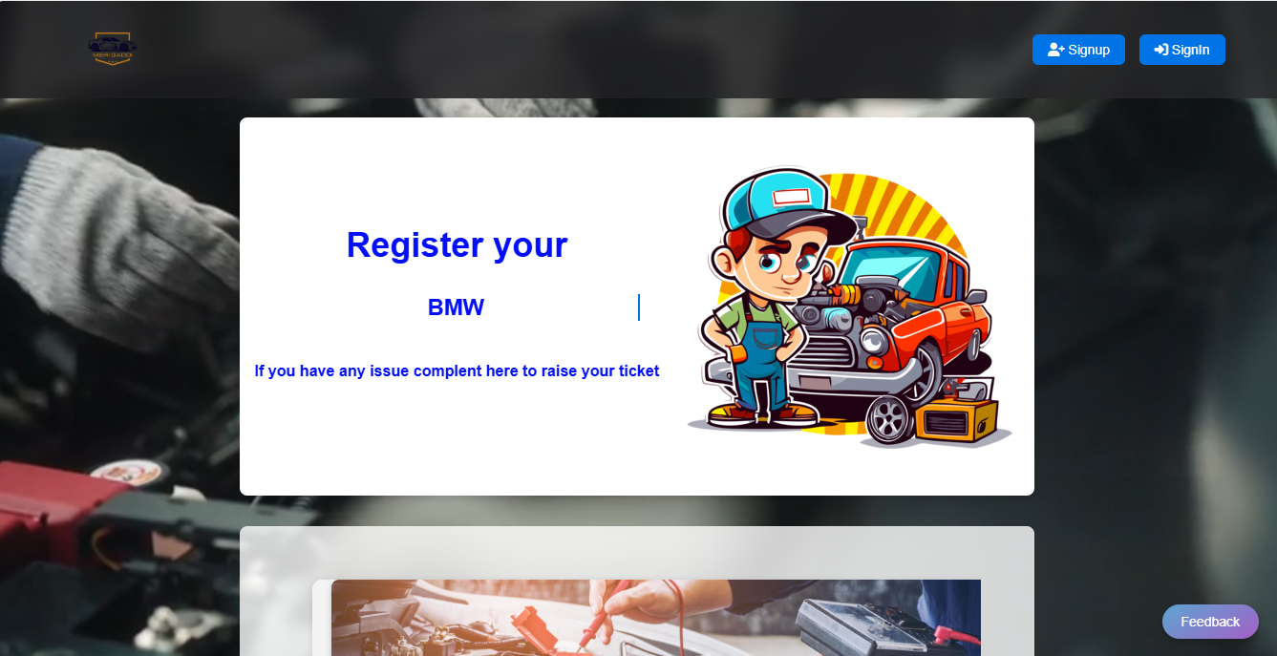

**SIGNUP PAGE**

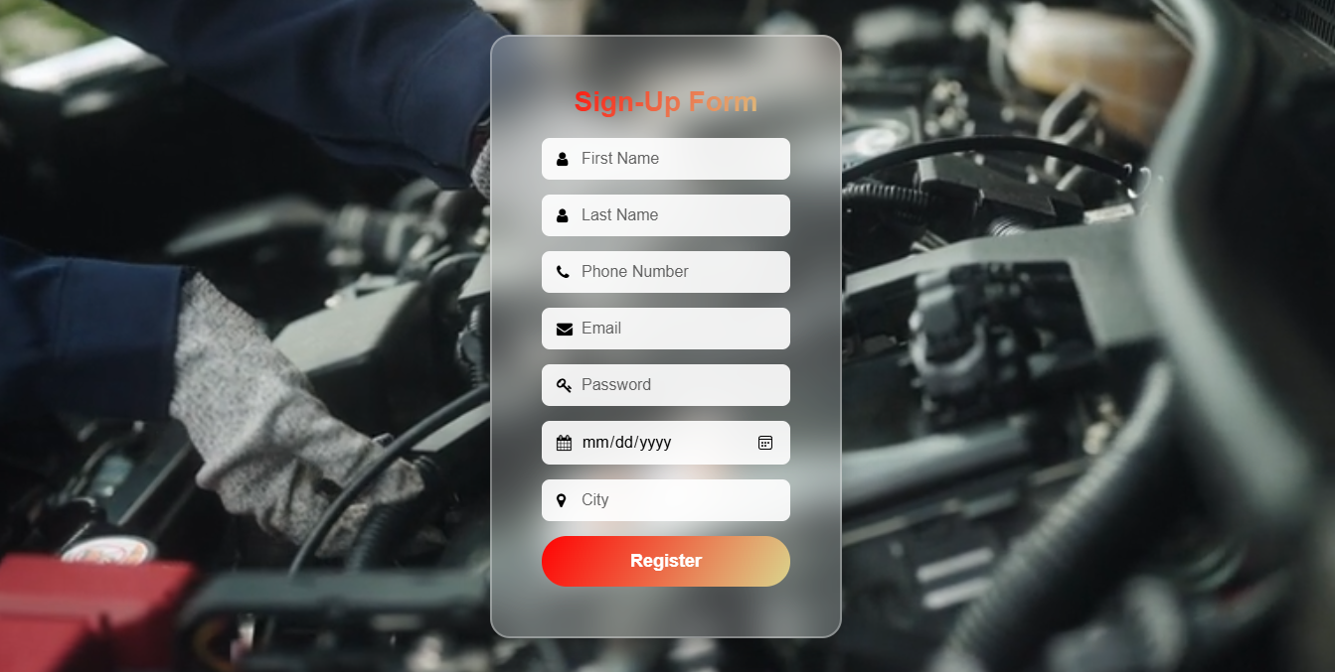

**LOGIN PAGE**

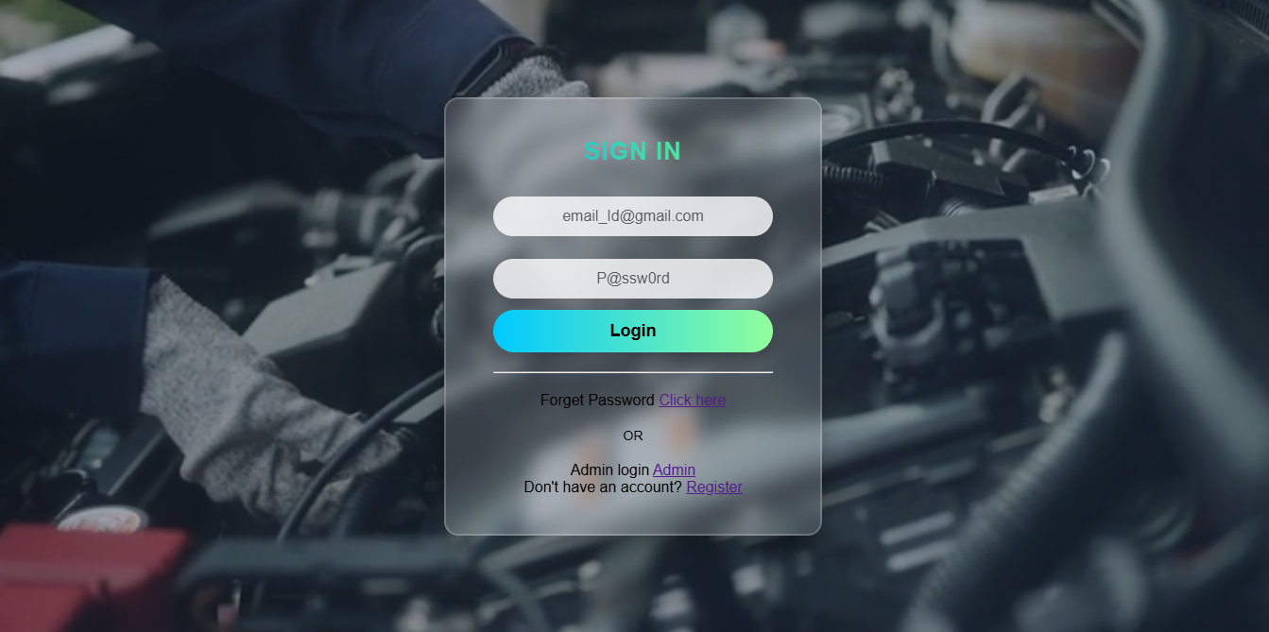

**HOME PAGE**

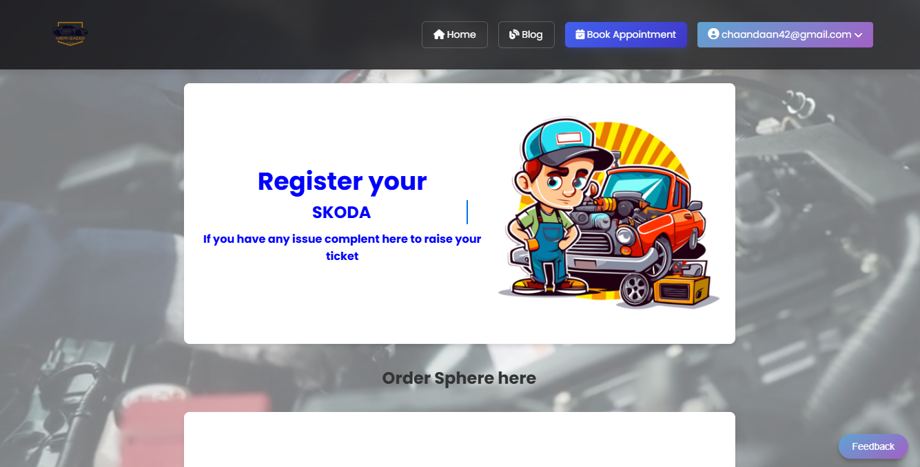

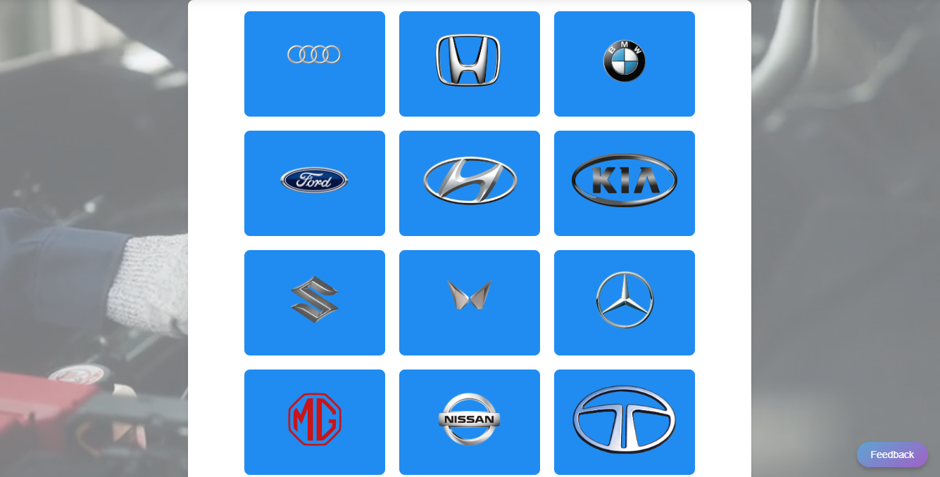

**APPOINTMENT SECTION**

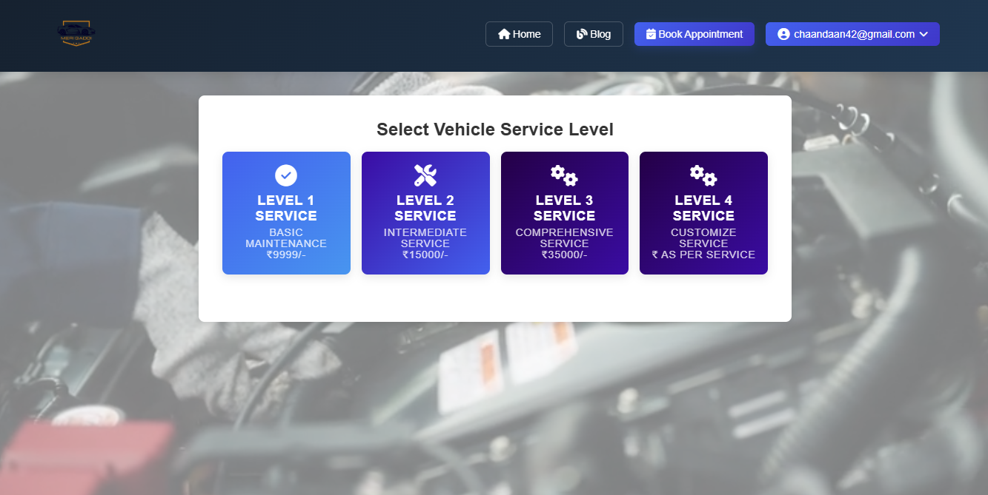

**ORDER DETAILS**

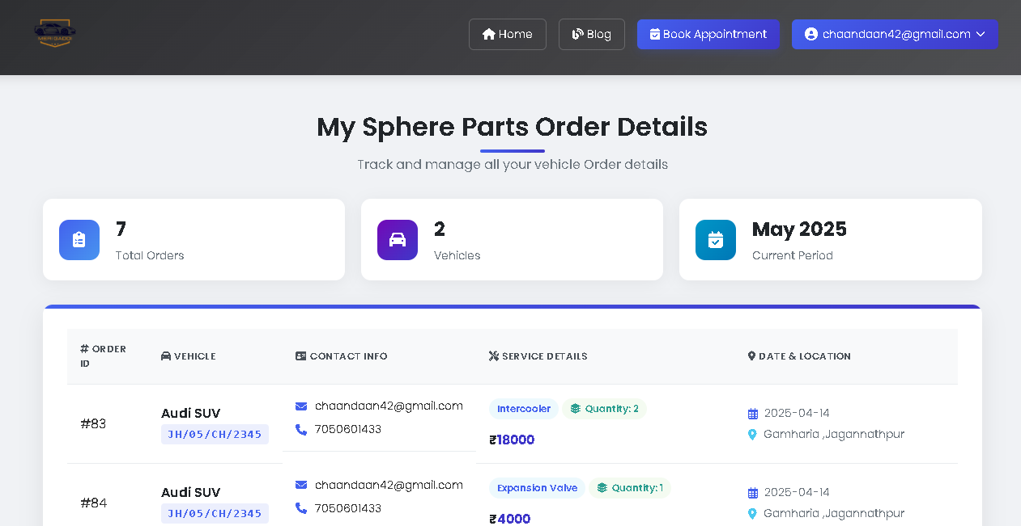

**APPOINTMENT HISTORY**

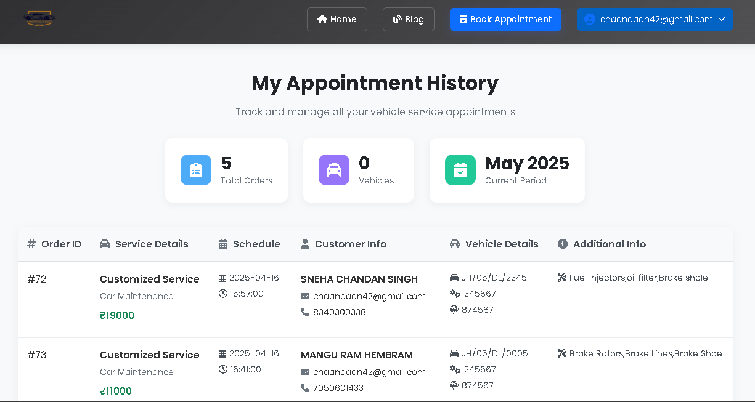

**ADMIN LOGIN**

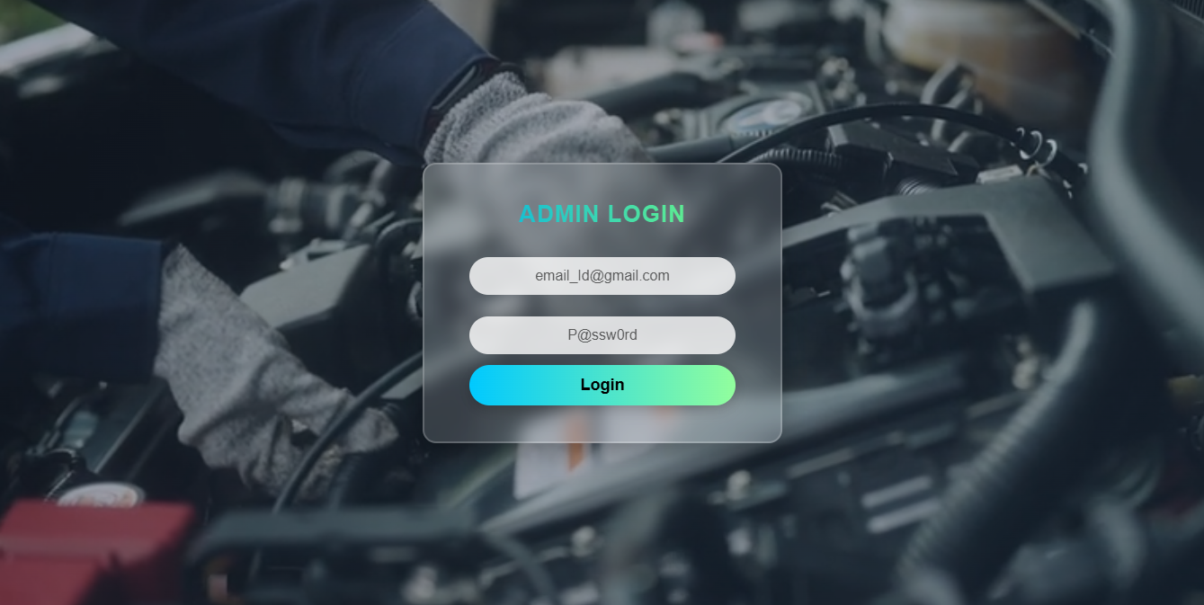

**ADMIN DASHBOARD**

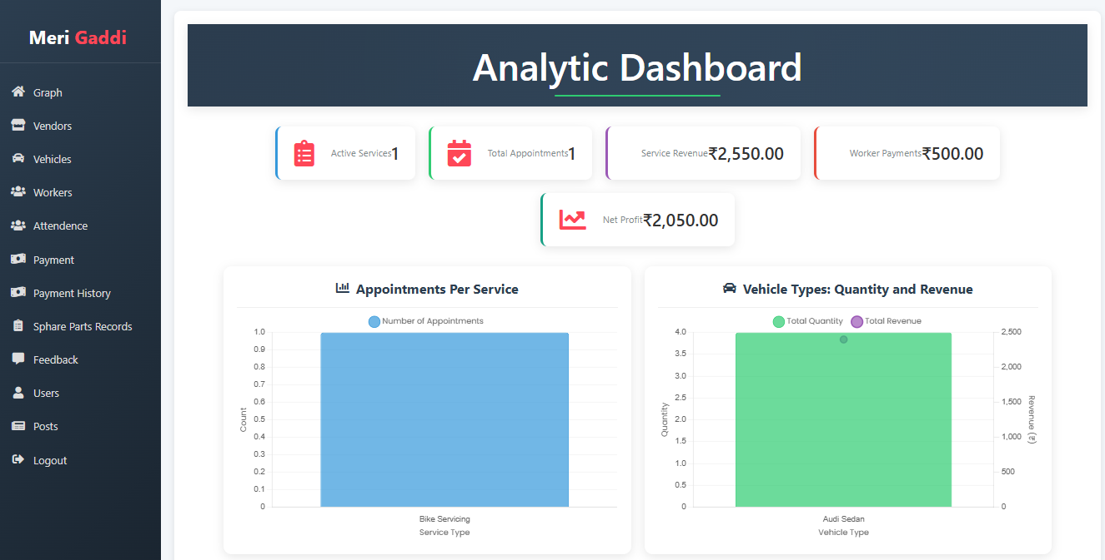

**VENDOR MANAGEMENT INTERFACE**

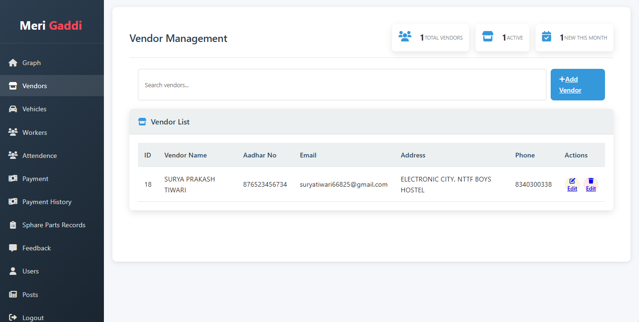

**APPOINTMENT MANAGEMENT INTERFACE**

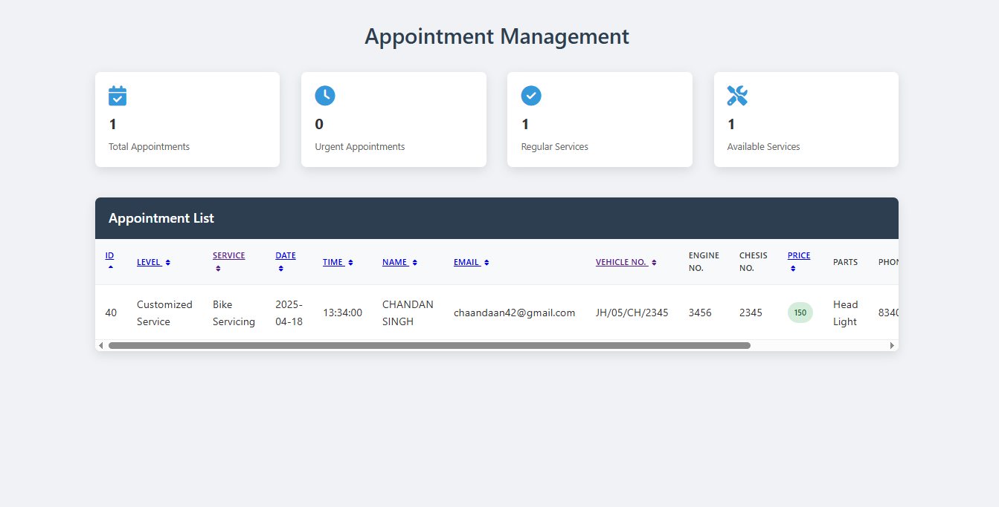

**STAFF MANAGEMENT INTERFACE**

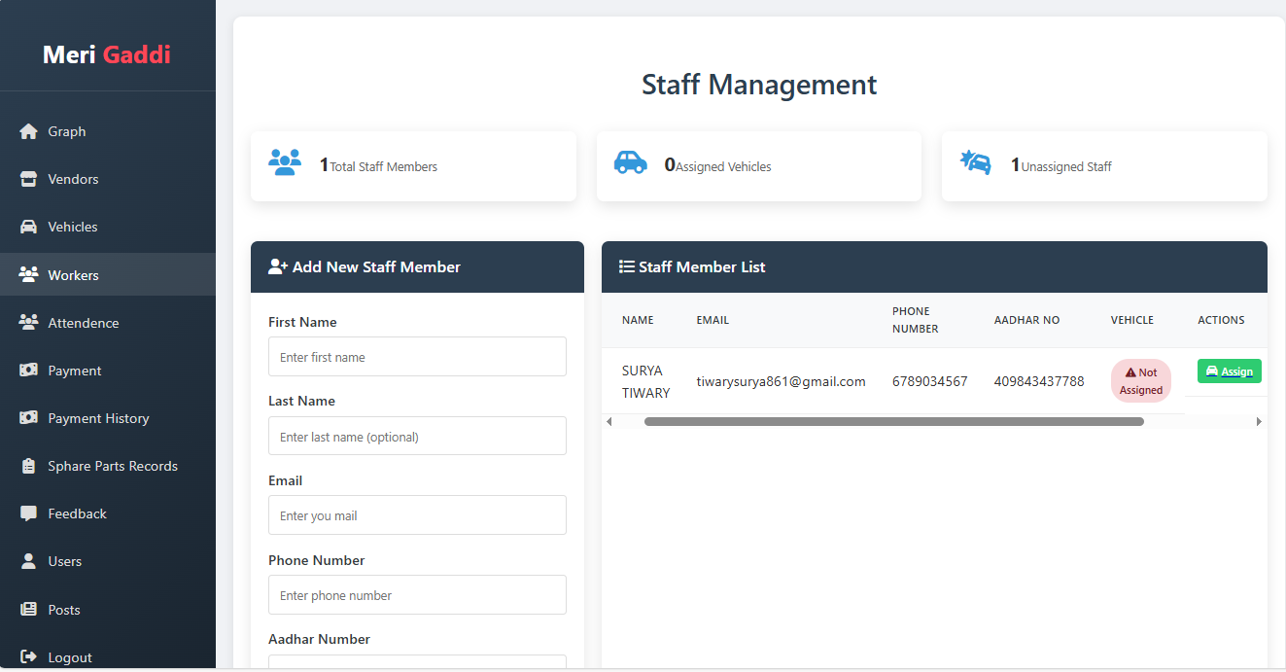

**ATTENDENCE SECTION**

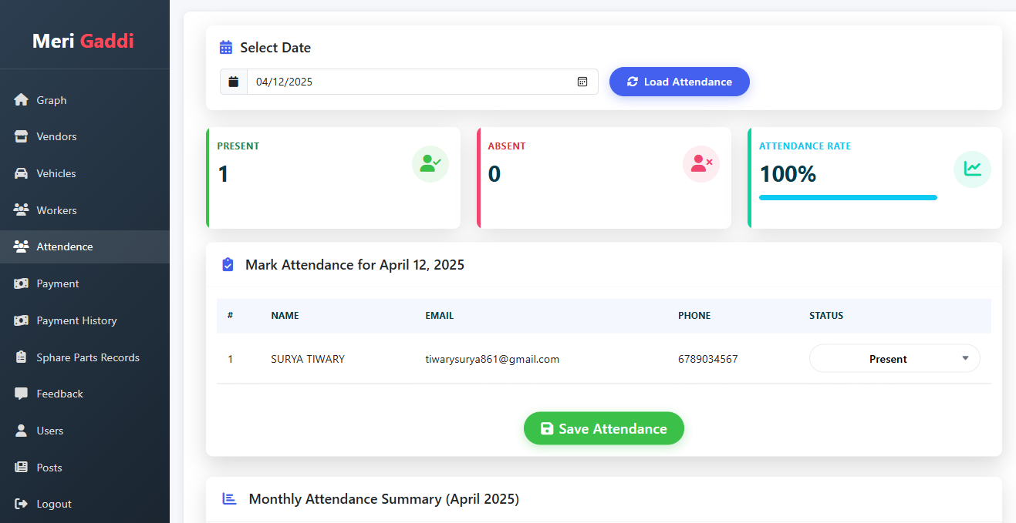

**WORKER PAYMENT SECTION**

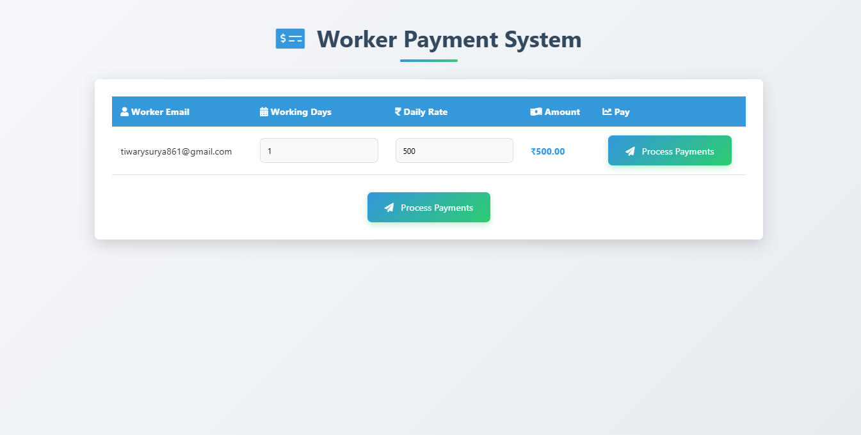

**PAYMENT HISTORY**

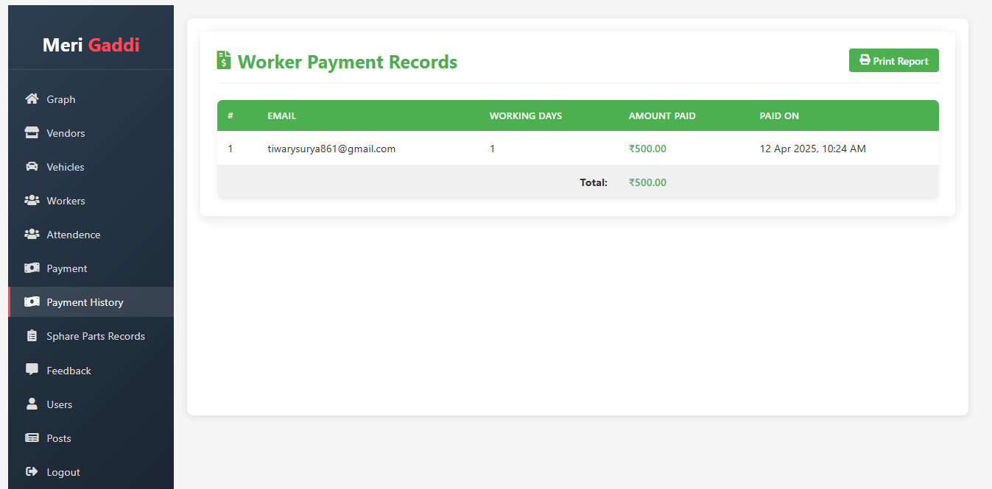

**SPHERE PARTS ORDER DETAILS**

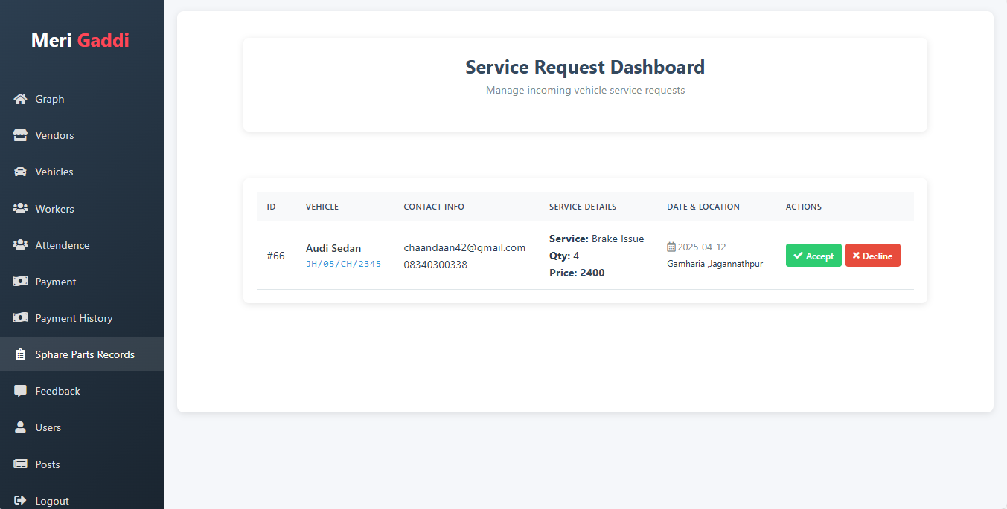

**FEEDBACK MANAGEMENT**

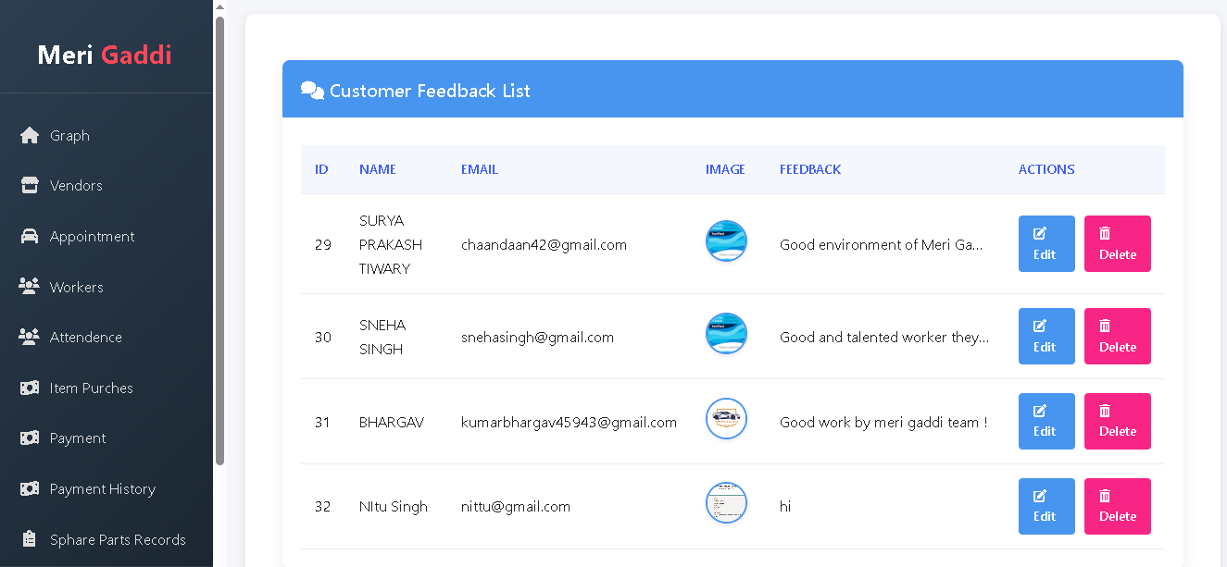

**USER MANAGEMENT**

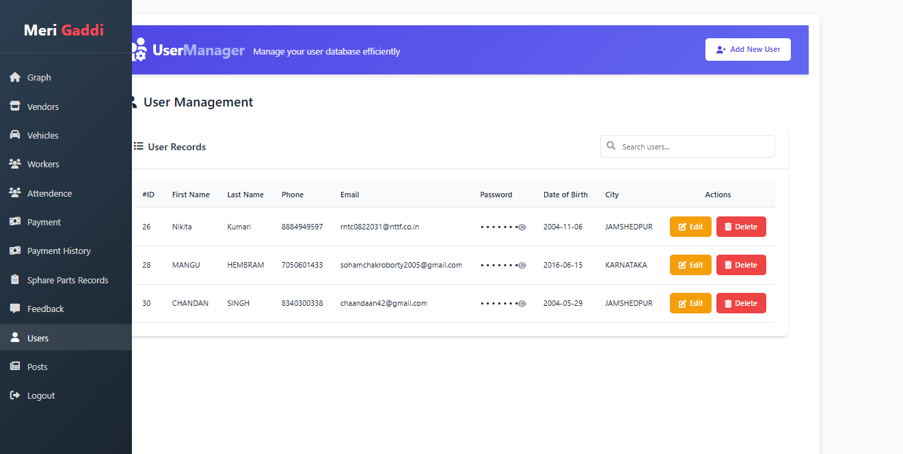

**POST MANAGEMENT**

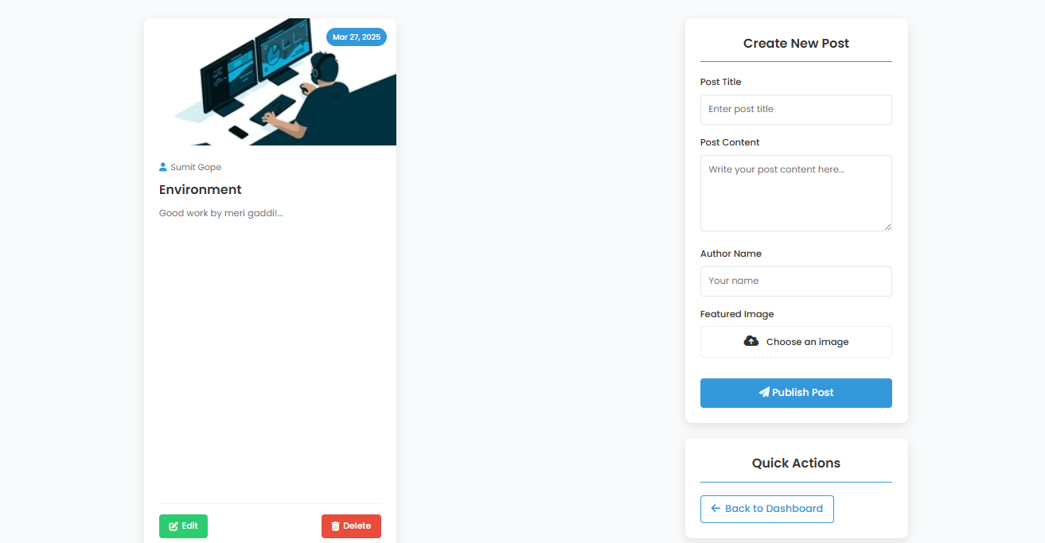

**CHAPTER-7**

**“DATA STRUCTURE OF THE PROJECT”**

**DATABASE**

A **database** is an organized collection of data that is stored and accessed electronically. It allows users to store, retrieve, manage, and manipulate data efficiently. A database can hold information such as customer records, inventory data, employee details, and much more.

### **Why is a Database Important?**

Databases are important because they:

1. **Store Large Amounts of Data** – Efficiently handle large volumes of information.
2. **Ensure Data Accuracy** – Reduce redundancy and ensure consistency.
3. **Allow Data Sharing** – Multiple users can access and use the data simultaneously.
4. **Improve Data Security** – Provide controlled access and encryption.
5. **Support Decision-Making** – Enable better business analysis and reporting.

### **Types of Databases (with Definitions)**

1. **Relational Database (RDBMS)**
   * **Definition**: Stores data in tables (rows and columns) with relationships between them.
   * **Examples**: MySQL, PostgreSQL, Oracle, SQL Server.
   * **Use Case**: Business applications like payroll, inventory, etc.
2. **NoSQL Database**
   * **Definition**: Stores data in a non-tabular format like key-value, document, graph, or column.
   * **Examples**: MongoDB (document), Redis (key-value), Cassandra (column), Neo4j (graph).
   * **Use Case**: Big data, real-time applications, unstructured data.
3. **Object-Oriented Database**
   * **Definition**: Stores data in the form of objects (like in object-oriented programming).
   * **Examples**: db4o, ObjectDB.
   * **Use Case**: Applications using object-oriented programming languages like Java or C++.
4. **Hierarchical Database**
   * **Definition**: Data is organized in a tree-like structure with parent-child relationships.
   * **Examples**: IBM Information Management System (IMS).
   * **Use Case**: Legacy systems, telecommunications.
5. **Network Database**
   * **Definition**: Similar to hierarchical but allows more complex relationships using a graph.
   * **Examples**: Integrated Data Store (IDS).
   * **Use Case**: Manufacturing, complex many-to-many relationships.
6. **Distributed Database**
   * **Definition**: Data is stored across different physical locations but appears as one database.
   * **Examples**: Apache Cassandra, Google Spanner.
   * **Use Case**: Global systems, cloud applications.
7. **Cloud Database**
   * **Definition**: Hosted on a cloud platform, accessible via the internet.
   * **Examples**: Amazon RDS, Google Cloud SQL, Azure SQL Database.
   * **Use Case**: Scalable online services and applications.
8. **Data Warehouse**
   * **Definition**: Specialized type of database optimized for reporting and data analysis.
   * **Examples**: Amazon Redshift, Snowflake, Google BigQuery.
   * **Use Case**: Business intelligence and analytics.

### **What is PHP MySQLi?**

**PHP MySQLi** stands for **PHP MySQL Improved**. It is an extension of PHP that allows you to **interact with MySQL databases**.

### ✅ **Breakdown of the Terms:**

* **PHP**: A server-side scripting language used to develop web applications.
* **MySQL**: A popular open-source relational database management system (RDBMS).
* **MySQLi**: A PHP extension (the "i" stands for "improved") that provides a more secure, efficient, and modern way to work with MySQL databases.

### 🔧 **Why Use MySQLi Instead of Old MySQL Extension?**

* **Supports prepared statements** (helps prevent SQL injection)
* **Supports object-oriented programming**
* **Faster and more secure**
* **Supports multiple statements and transactions**

**CLI OF THE DATABASE**

-- phpMyAdmin SQL Dump

-- version 5.2.1

-- https://www.phpmyadmin.net/

--

-- Host: 127.0.0.1

-- Generation Time: May 21, 2025 at 08:22 AM

-- Server version: 10.4.32-MariaDB

-- PHP Version: 8.2.12

SET SQL_MODE = "NO_AUTO_VALUE_ON_ZERO";

START TRANSACTION;

SET time_zone = "+00:00";

/*!40101 SET @OLD_CHARACTER_SET_CLIENT=@@CHARACTER_SET_CLIENT */;

/*!40101 SET @OLD_CHARACTER_SET_RESULTS=@@CHARACTER_SET_RESULTS */;

/*!40101 SET @OLD_COLLATION_CONNECTION=@@COLLATION_CONNECTION */;

/*!40101 SET NAMES utf8mb4 */;

--

-- Database: `final`

--

-- --------------------------------------------------------

--

-- Table structure for table `appointment`

--

CREATE TABLE `appointment` (

`ID` int(100) NOT NULL,

`LEVEL` varchar(20) NOT NULL,

`SERVICE` varchar(100) NOT NULL,

`TIME` time NOT NULL,

`DATE` date NOT NULL,

`NAME` varchar(30) NOT NULL,

`EMAIL` varchar(50) NOT NULL,

`VEHICLE_NO` varchar(14) NOT NULL,

`ENGINEE` int(20) NOT NULL,

`CHASIS` int(20) NOT NULL,

`PRICE` varchar(100) NOT NULL,

`PHONE_NUMBER` bigint(10) NOT NULL,

`SPHERE_PART` varchar(255) NOT NULL

) ENGINE=InnoDB DEFAULT CHARSET=utf8mb4 COLLATE=utf8mb4_general_ci;

--

-- Dumping data for table `appointment`

--

INSERT INTO `appointment` (`ID`, `LEVEL`, `SERVICE`, `TIME`, `DATE`, `NAME`, `EMAIL`, `VEHICLE_NO`, `ENGINEE`, `CHASIS`, `PRICE`, `PHONE_NUMBER`, `SPHERE_PART`) VALUES

(72, 'Customized Service', 'Car Maintenance', '15:57:00', '2025-04-16', 'SNEHA CHANDAN SINGH', 'chaandaan42@gmail.com', 'JH/05/DL/2345', 345667, 874567, '19000', 8340300338, 'Fuel Injectors,oil filter,Brake shole'),

(73, 'Customized Service', 'Car Maintenance', '16:41:00', '2025-04-16', 'MANGU RAM HEMBRAM', 'chaandaan42@gmail.com', 'JH/05/DL/0005', 345667, 874567, '11000', 7050601433, 'Brake Rotors,Brake Lines,Brake Shoe'),

(75, 'Level 3', 'Car Maintenance', '12:00:00', '2025-04-18', 'BHARGAV KUMAR', 'kumarbhargav45943@gmail.com', 'JH/05/MK/9834', 456789, 234567, '25000', 8340300338, ''),

(76, 'Customized Service', 'Bike Servicing', '23:01:00', '2025-04-17', 'BHARGAV KUMAR', 'kumarbhargav45943@gmail.com', 'JH/05/SH/9834', 456789, 234567, '26000', 8340300338, 'Brake Pads, Brake Rotors'),

(77, 'Customized Service', 'Bike Servicing', '10:15:00', '2025-04-18', 'CHANDAN SINGH', 'chaandaan42@gmail.com', 'JH/05/dH/2345', 345667, 874567, '11000', 8340300338, 'Brake Rotors, Brake Lines'),

(78, 'Level 2', 'Bike Servicing', '10:16:00', '2025-04-18', 'CHANDAN SINGH', 'chaandaan42@gmail.com', 'JH/05/CH/1688', 345667, 874567, '10000', 8340300338, ''),

(79, 'Customized Service', 'Car Maintenance', '00:04:00', '2025-04-22', 'MRINMOY KUMAR MAHATO', 'mrinmoykumarmahato@gmail.com', 'JH/05/DH/2345', 345667, 874567, '8000', 8340300338, 'Brake Pads, Brake Lines'),

(80, 'Customized Service', 'Car Maintenance', '01:06:00', '2025-04-23', 'MRINMOY KUMAR MAHATO', 'mrinmoykumarmahato@gmail.com', 'JH/05/DH/2345', 345667, 874567, '13000', 8340300338, 'Brake Pads, Brake Rotors'),

(81, 'Customized Service', 'Bike Servicing', '20:06:00', '2025-04-30', 'MRINMOY KUMAR MAHATO', 'chaandaan42@gmail.com', 'JH/05/DH/2345', 345667, 874567, '30000', 8340300338, 'Brake Calipers, Brake Lines');

-- --------------------------------------------------------

--

-- Table structure for table `attendance`

--

CREATE TABLE `attendance` (

`id` int(11) NOT NULL,

`email` varchar(255) DEFAULT NULL,

`date` date DEFAULT NULL,

`status` varchar(10) DEFAULT NULL

) ENGINE=InnoDB DEFAULT CHARSET=utf8mb4 COLLATE=utf8mb4_general_ci;

--

-- Dumping data for table `attendance`

--

INSERT INTO `attendance` (`id`, `email`, `date`, `status`) VALUES

(21, 'tiwarysurya861@gmail.com', '2025-04-12', 'Present'),

(22, 'tiwarysurya861@gmail.com', '2025-04-13', 'Present'),

(23, 'tiwarysurya861@gmail.com', '2025-04-14', 'Present'),

(24, 'manguramhembram@gmail.com', '2025-04-14', 'Present'),

(25, 'tiwarysurya861@gmail.com', '2025-04-15', 'Present'),

(26, 'manguramhembram@gmail.com', '2025-04-15', 'Present'),

(27, 'kumarbhargav45943@gmail.com', '2025-04-15', 'Absent'),

(28, 'tiwarysurya861@gmail.com', '2025-04-30', 'Present'),

(29, 'manguramhembram@gmail.com', '2025-04-30', 'Absent'),

(30, 'kumarbhargav45943@gmail.com', '2025-04-30', 'Present');

-- --------------------------------------------------------

--

-- Table structure for table `emergency_appointment`

--

CREATE TABLE `emergency_appointment` (

`ID` int(100) NOT NULL,

`SERVICE` varchar(20) NOT NULL DEFAULT 'EMERG APPOINT',

`DATE` date NOT NULL,

`TIME` time(6) NOT NULL,

`NAME` varchar(20) NOT NULL,

`VEHICLE_NO` varchar(14) NOT NULL,

`WANT` varchar(100) NOT NULL,

`SPHERE_PART` varchar(10) NOT NULL,

`PHONE_NUMBER` bigint(10) NOT NULL

) ENGINE=InnoDB DEFAULT CHARSET=utf8mb4 COLLATE=utf8mb4_general_ci;

--

-- Dumping data for table `emergency_appointment`

--

INSERT INTO `emergency_appointment` (`ID`, `SERVICE`, `DATE`, `TIME`, `NAME`, `VEHICLE_NO`, `WANT`, `SPHERE_PART`, `PHONE_NUMBER`) VALUES

(1, 'Emergency Repair', '2025-02-18', '00:00:00.000000', 'CHANDAN SINGH ', '', '', '', 0),

(2, 'Emergency Repair', '2025-02-18', '23:00:00.000000', 'SNEHA SINGH', '', '', '', 0),

(3, 'Emergency Repair', '2025-02-21', '14:11:00.000000', 'SNEHA SINGH', '', '', '', 0),

(4, 'Emergency Repair', '2025-02-13', '14:33:00.000000', 'Soham ', '', '', '', 0),

(5, 'Emergency Repair', '2025-02-13', '14:33:00.000000', 'Soham ', '', '', '', 0),

(6, 'Emergency Repair', '2004-02-20', '17:04:00.000000', 'Sukhbir Singh', '', '', '', 0),

(7, 'Emergency Repair', '2025-03-04', '14:12:00.000000', 'CHANDAN SINGH', 'JH/05/DL/9834', 'Brake Issue', '', 0);

-- --------------------------------------------------------

--

-- Table structure for table `feedback`

--

CREATE TABLE `feedback` (

`ID` int(100) NOT NULL,

`NAME` varchar(50) NOT NULL,

`EMAIL` varchar(50) NOT NULL,

`IMAGE` varchar(255) NOT NULL,

`FEEDBACK` varchar(500) NOT NULL

) ENGINE=InnoDB DEFAULT CHARSET=utf8mb4 COLLATE=utf8mb4_general_ci;

--

-- Dumping data for table `feedback`

--

INSERT INTO `feedback` (`ID`, `NAME`, `EMAIL`, `IMAGE`, `FEEDBACK`) VALUES

(29, 'SURYA PRAKASH TIWARY', 'chaandaan42@gmail.com', 'python-essentials-2 (1).png', 'Good environment of Meri Gaddi !'),

(30, 'SNEHA SINGH', 'snehasingh@gmail.com', 'python-essentials-2 (1).png', 'Good and talented worker they have !'),

(31, 'BHARGAV', 'kumarbhargav45943@gmail.com', 'Blue Gold Minimalist Car Showroom Logo.png', 'Good work by meri gaddi team !'),

(32, 'NItu Singh', 'nittu@gmail.com', 'Capture.PNG', 'hi');

-- --------------------------------------------------------

--

-- Table structure for table `inventory`

--

CREATE TABLE `inventory` (

`id` int(11) NOT NULL,

`product_name` varchar(255) DEFAULT NULL,

`price` decimal(10,2) DEFAULT NULL,

`quantity` int(11) DEFAULT NULL,

`vendor_name` varchar(255) DEFAULT NULL,

`total_price` decimal(10,2) DEFAULT NULL,

`date_time` varchar(10) NOT NULL DEFAULT current_timestamp()

) ENGINE=InnoDB DEFAULT CHARSET=utf8mb4 COLLATE=utf8mb4_general_ci;

--

-- Dumping data for table `inventory`

--

INSERT INTO `inventory` (`id`, `product_name`, `price`, `quantity`, `vendor_name`, `total_price`, `date_time`) VALUES

(8, 'Filter', 350.00, 7, 'SOHAM CHAKROBARTY', 2450.00, '2025-04-13'),

(9, 'Filter', 300.00, 4, 'SOHAM CHAKROBARTY', 1200.00, '2025-04-13');

-- --------------------------------------------------------

--

-- Table structure for table `members`

--

CREATE TABLE `members` (

`id` int(11) NOT NULL,

`firstname` varchar(50) NOT NULL,

`lastname` varchar(50) DEFAULT NULL,

`email` varchar(50) NOT NULL,

`phoneNumber` varchar(15) NOT NULL,

`aadharNo` varchar(20) NOT NULL,

`vehicle` varchar(255) DEFAULT NULL

) ENGINE=InnoDB DEFAULT CHARSET=utf8mb4 COLLATE=utf8mb4_general_ci;

--

-- Dumping data for table `members`

--

INSERT INTO `members` (`id`, `firstname`, `lastname`, `email`, `phoneNumber`, `aadharNo`, `vehicle`) VALUES

(39, 'SURYA', 'TIWARY', 'tiwarysurya861@gmail.com', '6789034567', '409843437788', 'JH/05/SH/9834'),

(40, 'MANGU', 'HEMBRAM', 'manguramhembram@gmail.com', '7903428956', '789623457638', 'JH/05/DH/2345'),

(41, 'BHARGAV', 'KUMAR', 'kumarbhargav45943@gmail.com', '8340300338', '897634567856', 'JH/05/MK/9834');

-- --------------------------------------------------------

--

-- Table structure for table `payments`

--

CREATE TABLE `payments` (

`id` int(11) NOT NULL,

`email` varchar(50) NOT NULL,

`working_days` int(11) NOT NULL,

`amount_paid` decimal(10,2) NOT NULL,

`payment_date` datetime DEFAULT current_timestamp()

) ENGINE=InnoDB DEFAULT CHARSET=utf8mb4 COLLATE=utf8mb4_general_ci;

--

-- Dumping data for table `payments`

--

INSERT INTO `payments` (`id`, `email`, `working_days`, `amount_paid`, `payment_date`) VALUES

(37, 'tiwarysurya861@gmail.com', 1, 500.00, '2025-04-12 13:54:41'),

(38, 'tiwarysurya861@gmail.com', 2, 1000.00, '2025-04-13 12:07:19'),

(44, 'manguramhembram@gmail.com', 2, 1000.00, '2025-04-15 23:08:26'),

(45, 'tiwarysurya861@gmail.com', 4, 2000.00, '2025-04-15 23:08:29'),

(46, 'kumarbhargav45943@gmail.com', 1, 500.00, '2025-04-15 23:08:49'),

(47, 'manguramhembram@gmail.com', 2, 1000.00, '2025-04-15 23:08:54'),

(48, 'tiwarysurya861@gmail.com', 4, 2000.00, '2025-04-15 23:08:58'),

(49, 'kumarbhargav45943@gmail.com', 1, 500.00, '2025-04-30 21:51:51'),

(50, 'manguramhembram@gmail.com', 2, 1000.00, '2025-04-30 21:51:56'),

(51, 'tiwarysurya861@gmail.com', 5, 2500.00, '2025-04-30 21:52:02');

-- --------------------------------------------------------

--

-- Table structure for table `posts`

--

CREATE TABLE `posts` (

`ID` int(11) NOT NULL,

`TITLE` varchar(100) NOT NULL,

`IMAGE` varchar(255) NOT NULL,

`CONTENT` varchar(500) NOT NULL,

`NAME` varchar(100) NOT NULL,

`DATE` date NOT NULL DEFAULT current_timestamp()

) ENGINE=InnoDB DEFAULT CHARSET=utf8mb4 COLLATE=utf8mb4_general_ci;

--

-- Dumping data for table `posts`

--

INSERT INTO `posts` (`ID`, `TITLE`, `IMAGE`, `CONTENT`, `NAME`, `DATE`) VALUES

(37, 'Environment', 'uploads/200.webp', 'Good work by meri gaddi!', 'Sumit Gope', '2025-03-27');

-- --------------------------------------------------------

--

-- Table structure for table `service`

--

CREATE TABLE `service` (

`ID` int(100) NOT NULL,

`V_TYPE` varchar(20) NOT NULL,

`V_NUMBER` varchar(14) NOT NULL,

`EMAIL` varchar(30) NOT NULL,

`PHONE` varchar(12) NOT NULL,

`WANT` varchar(500) NOT NULL,

`DATE` date NOT NULL DEFAULT current_timestamp(),

`PRICE` int(100) NOT NULL,

`QUANTITY` int(10) NOT NULL,

`ADDRESS` varchar(50) NOT NULL,

`SESSION_ID` varchar(100) NOT NULL

) ENGINE=InnoDB DEFAULT CHARSET=utf8mb4 COLLATE=utf8mb4_general_ci;

--

-- Dumping data for table `service`

--

INSERT INTO `service` (`ID`, `V_TYPE`, `V_NUMBER`, `EMAIL`, `PHONE`, `WANT`, `DATE`, `PRICE`, `QUANTITY`, `ADDRESS`, `SESSION_ID`) VALUES

(82, '2 Wheelers BMW', 'JH/05/CH/2345', 'manguramhembram@gmail.com', '8340300338', 'Tire Change', '2025-04-14', 2000, 4, 'Gamharia ,Jagannathpur', ''),

(83, 'Audi SUV', 'JH/05/CH/2345', 'chaandaan42@gmail.com', '7050601433', 'Intercooler', '2025-04-14', 18000, 2, 'Gamharia ,Jagannathpur', ''),

(84, 'Audi SUV', 'JH/05/CH/2345', 'chaandaan42@gmail.com', '7050601433', 'Expansion Valve', '2025-04-14', 4000, 1, 'Gamharia ,Jagannathpur', ''),

(85, 'Audi SUV', 'JH/05/CH/2345', 'chaandaan42@gmail.com', '7050601433', 'Tire Change,Mobil Ch', '2025-04-14', 3600, 3, 'Gamharia ,Jagannathpur', ''),

(86, '2 Wheelers AUDI', 'JH/05/CH/2345', 'chaandaan42@gmail.com', '7050601433', 'Mobil Change,Brake S', '2025-04-14', 1050, 1, 'ELECTRONIC CITY, NTTF BOYS HOSTEL', ''),

(94, '4 Wheelers Tata', 'JH/05/CH/2345', 'chaandaan42@gmail.com', '8340300338', 'Brake Pads,Brake Rotors', '2025-04-14', 13000, 1, 'Gamharia ,Jagannathpur', ''),

(96, '4 Wheelers BMW', 'JH/05/KL/2345', 'chaandaan42@gmail.com', '8340300338', 'Starter Motor,Tail Light Assembly', '2025-04-17', 19000, 1, 'ELECTRONIC CITY, NTTF BOYS HOSTEL', ''),

(97, '4 Wheelers Ford', 'JH/05/KL/2345', 'chaandaan42@gmail.com', '8340300338', 'Clutch Kit', '2025-04-30', 30000, 2, 'ELECTRONIC CITY, NTTF BOYS HOSTEL', '');

-- --------------------------------------------------------

--

-- Table structure for table `user`

--

CREATE TABLE `user` (

`ID` int(12) NOT NULL,

`FirstName` varchar(30) NOT NULL,

`LastName` varchar(30) NOT NULL,

`Phone` bigint(10) NOT NULL,

`Mail` varchar(30) NOT NULL,

`Password` varchar(16) NOT NULL,

`DOB` date NOT NULL,

`City` varchar(20) NOT NULL

) ENGINE=InnoDB DEFAULT CHARSET=utf8mb4 COLLATE=utf8mb4_general_ci;

--

-- Dumping data for table `user`

--

INSERT INTO `user` (`ID`, `FirstName`, `LastName`, `Phone`, `Mail`, `Password`, `DOB`, `City`) VALUES

(35, 'CHANDAN ', ' SINGH', 8340300338, 'chaandaan42@gmail.com', 'AarChaRan@1903', '2004-05-29', 'JAMSHEDPUR'),

(36, 'BHARGAV', 'KUMAR', 8340300338, 'kumarbhargav45943@gmail.com', 'P@ssw0rd', '2004-05-29', 'BANGALORE'),

(37, 'MRINMOY KUMAR ', 'MAHATO', 8340300338, 'mrinmoykumarmahato@gmail.com', 'P@ssw0rd', '2002-03-23', 'Sonari');

-- --------------------------------------------------------

--

-- Table structure for table `vendor`

--

CREATE TABLE `vendor` (

`ID` int(100) NOT NULL,

`VEN_NAME` varchar(50) NOT NULL,

`AADHAR_NO` varchar(12) NOT NULL,

`EMAIL` varchar(50) NOT NULL,

`ADDRESS` varchar(100) NOT NULL,

`PHONE` varchar(12) NOT NULL

) ENGINE=InnoDB DEFAULT CHARSET=utf8mb4 COLLATE=utf8mb4_general_ci;

--

-- Dumping data for table `vendor`

--

INSERT INTO `vendor` (`ID`, `VEN_NAME`, `AADHAR_NO`, `EMAIL`, `ADDRESS`, `PHONE`) VALUES

(18, 'SURYA PRAKASH TIWARI', '876523456734', 'suryatiwari66825@gmail.com', 'ELECTRONIC CITY, NTTF BOYS HOSTEL', '8340300338'),

(19, 'BHARGAV', '876523456789', 'kumarbhargav45943@gmail.com', 'ELECTRONIC CITY NTTF BOYS HOSTEL', '8340300338');

--

-- Indexes for dumped tables

--

--

-- Indexes for table `appointment`

--

ALTER TABLE `appointment`

ADD PRIMARY KEY (`ID`);

--

-- Indexes for table `attendance`

--

ALTER TABLE `attendance`

ADD PRIMARY KEY (`id`);

--

-- Indexes for table `emergency_appointment`

--

ALTER TABLE `emergency_appointment`

ADD PRIMARY KEY (`ID`);

--

-- Indexes for table `feedback`

--

ALTER TABLE `feedback`

ADD PRIMARY KEY (`ID`);

--

-- Indexes for table `inventory`

--

ALTER TABLE `inventory`

ADD PRIMARY KEY (`id`);

--

-- Indexes for table `members`

--

ALTER TABLE `members`

ADD PRIMARY KEY (`id`),

ADD UNIQUE KEY `phoneNumber` (`phoneNumber`),

ADD UNIQUE KEY `aadharNo` (`aadharNo`),

ADD UNIQUE KEY `email` (`email`);

--

-- Indexes for table `payments`

--

ALTER TABLE `payments`

ADD PRIMARY KEY (`id`),

ADD KEY `fk_child_id` (`email`);

--

-- Indexes for table `posts`

--

ALTER TABLE `posts`

ADD PRIMARY KEY (`ID`);

--

-- Indexes for table `service`

--

ALTER TABLE `service`

ADD PRIMARY KEY (`ID`);

--

-- Indexes for table `user`

--

ALTER TABLE `user`

ADD PRIMARY KEY (`ID`);

--

-- Indexes for table `vendor`

--

ALTER TABLE `vendor`

ADD PRIMARY KEY (`ID`);

--

-- AUTO_INCREMENT for dumped tables

--

--

-- AUTO_INCREMENT for table `appointment`

--

ALTER TABLE `appointment`

MODIFY `ID` int(100) NOT NULL AUTO_INCREMENT, AUTO_INCREMENT=82;

--

-- AUTO_INCREMENT for table `attendance`

--

ALTER TABLE `attendance`

MODIFY `id` int(11) NOT NULL AUTO_INCREMENT, AUTO_INCREMENT=31;

--

-- AUTO_INCREMENT for table `emergency_appointment`

--

ALTER TABLE `emergency_appointment`

MODIFY `ID` int(100) NOT NULL AUTO_INCREMENT, AUTO_INCREMENT=8;

--

-- AUTO_INCREMENT for table `feedback`

--

ALTER TABLE `feedback`

MODIFY `ID` int(100) NOT NULL AUTO_INCREMENT, AUTO_INCREMENT=33;

--

-- AUTO_INCREMENT for table `inventory`

--

ALTER TABLE `inventory`

MODIFY `id` int(11) NOT NULL AUTO_INCREMENT, AUTO_INCREMENT=10;

--

-- AUTO_INCREMENT for table `members`

--

ALTER TABLE `members`

MODIFY `id` int(11) NOT NULL AUTO_INCREMENT, AUTO_INCREMENT=42;

--

-- AUTO_INCREMENT for table `payments`

--

ALTER TABLE `payments`

MODIFY `id` int(11) NOT NULL AUTO_INCREMENT, AUTO_INCREMENT=52;

--

-- AUTO_INCREMENT for table `posts`

--

ALTER TABLE `posts`

MODIFY `ID` int(11) NOT NULL AUTO_INCREMENT, AUTO_INCREMENT=41;

--

-- AUTO_INCREMENT for table `service`

--

ALTER TABLE `service`

MODIFY `ID` int(100) NOT NULL AUTO_INCREMENT, AUTO_INCREMENT=98;

--

-- AUTO_INCREMENT for table `user`

--

ALTER TABLE `user`

MODIFY `ID` int(12) NOT NULL AUTO_INCREMENT, AUTO_INCREMENT=38;

--

-- AUTO_INCREMENT for table `vendor`

--

ALTER TABLE `vendor`

MODIFY `ID` int(100) NOT NULL AUTO_INCREMENT, AUTO_INCREMENT=20;

COMMIT;

/*!40101 SET CHARACTER_SET_CLIENT=@OLD_CHARACTER_SET_CLIENT */;

/*!40101 SET CHARACTER_SET_RESULTS=@OLD_CHARACTER_SET_RESULTS */;

/*!40101 SET COLLATION_CONNECTION=@OLD_COLLATION_CONNECTION */;

**VISUAL OF THE DATABASE**

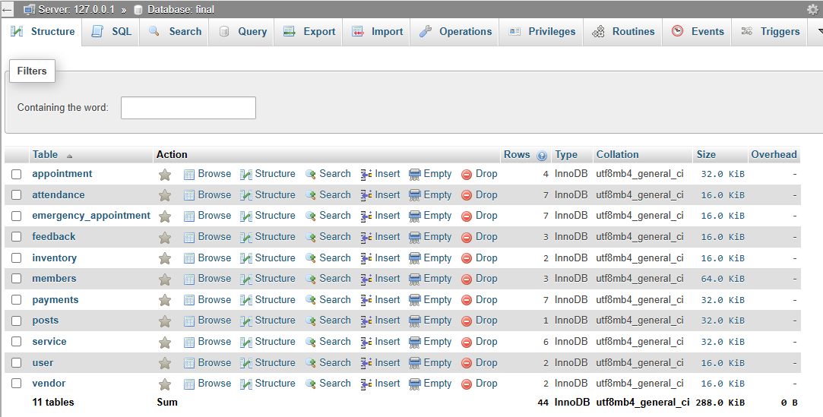

**APPOINTMENT TABLE**

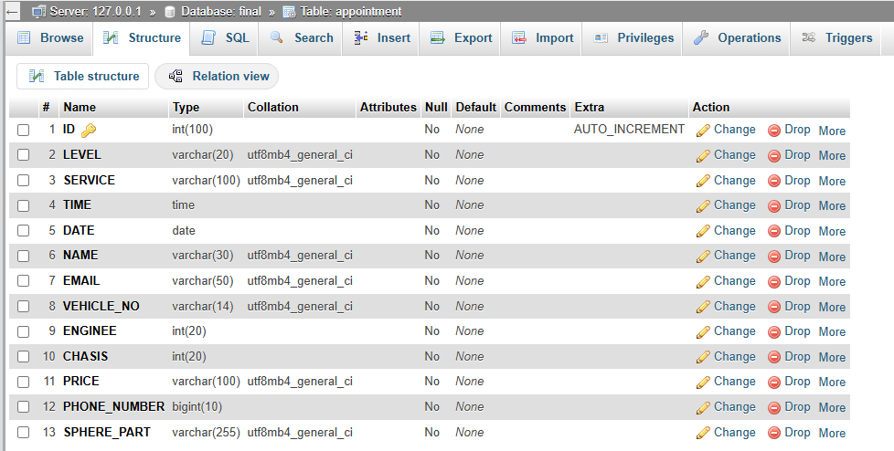

**ATTENDENCE TABLE**

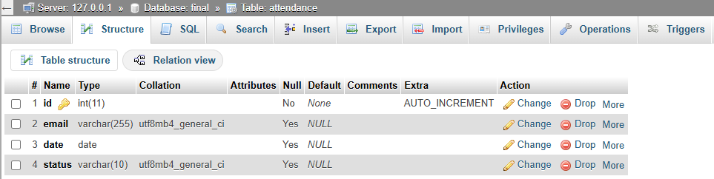

**FEEDBACK TABLE**

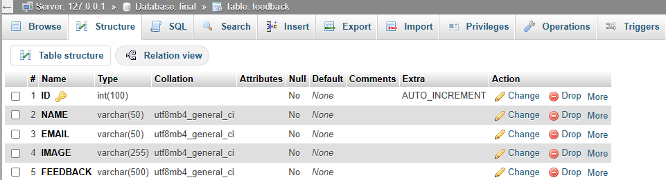

**INVENTORY TABLE**

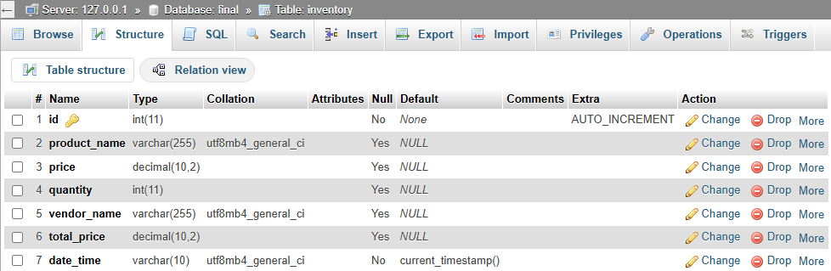

**MEMBER TABLE(WORKERS)**

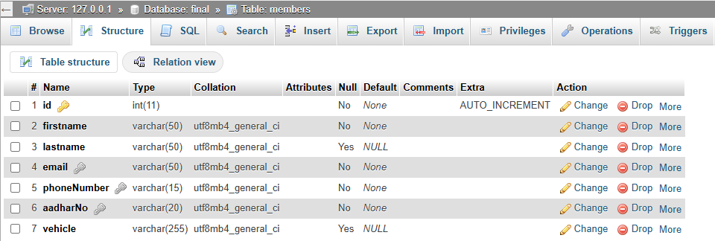

**PAYMENT TABLE**

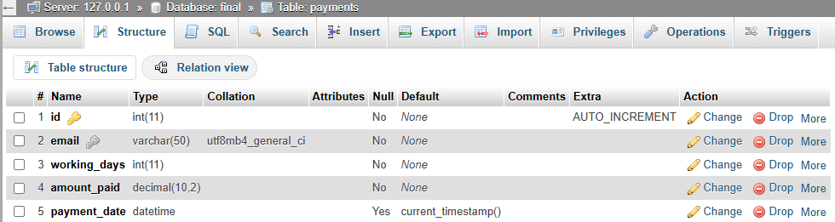

**POST TABLE**

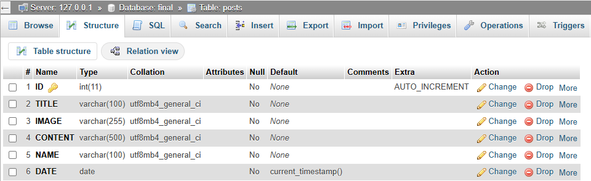

**SERVICE TABLE(SPHERE PARTS ORDER)**

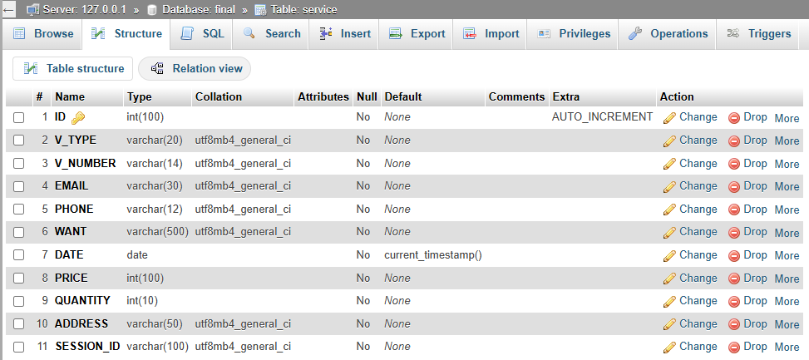

**USER TABLE**

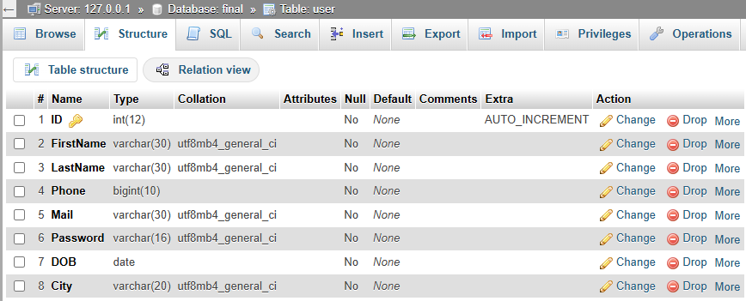

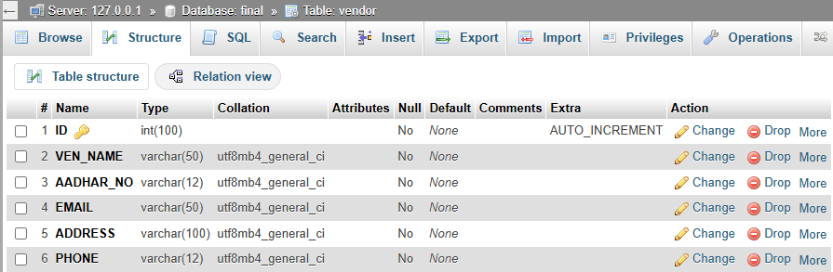**VENDOR TABLE**

**BIBLOGRAPHY**

For the successful completion of the project we have taken references from:-

* W3school.com

**W3Schools** is a **popular online learning platform** for web development. It provides **free tutorials, references, and examples** for various programming and web technologies.

### 📘 **What W3Schools Offers:**

* **Tutorials and References** on:
  + HTML, CSS, JavaScript
  + PHP, SQL, Python
  + MySQL, Bootstrap, jQuery
  + React, Node.js, and more
* **Try-It-Yourself Editor**  
  Lets you test and run code directly in the browser.
* **Quizzes and Exercises**  
  Helps reinforce your learning with interactive questions.
* **Certification Programs**  
  You can pay to get a certificate in topics like HTML, CSS, JavaScript, PHP, etc.
* Fontawsome.com

**Font Awesome** is a **popular icon library** that provides **scalable vector icons** you can use in websites and applications. It includes **free and pro icons** in categories like UI, social media, arrows, etc.

### ✅ **Why Use Font Awesome?**

* **Easy to use** with HTML and CSS
* **Scalable**: icons scale like fonts, without loss of quality
* **Customizable**: change size, color, shadows, and more using CSS
* **Thousands of icons**: free and paid sets available
* Geeksforgeeks.com

**GeeksforGeeks (GFG)** is a **popular online platform** for learning programming, data structures, algorithms, computer science fundamentals, and interview preparation. It's widely used by students, developers, and job seekers.

### 🌐 **Official Website**

👉 <https://www.geeksforgeeks.org>

### 📌 **Key Features of GeeksforGeeks:**

| **Feature** | **Description** |
| --- | --- |
| **Programming Tutorials** | Covers C, C++, Java, Python, JavaScript, etc. |
| **Data Structures & Algorithms (DSA)** | In-depth articles, code examples, and visualizations. |
| **Interview Preparation** | Covers coding questions asked by companies like Google, Amazon, TCS, Infosys, etc. |
| **Practice Problems** | Coding practice with varying levels (easy to hard). |
| **Quizzes & MCQs** | On core subjects like OS, DBMS, Networking, etc. |
| **Courses & Certificates** | Paid and free courses on DSA, Web Dev, System Design, etc. |
| **Coding Platform** | practice.geeksforgeeks.org for solving problems online. |

* Github.com

**GitHub** is a **web-based platform** used for **version control**, **collaboration**, and **code hosting**. It is built around **Git**, a distributed version control system created by Linus Torvalds.

### 🌐 **Official Website**

👉 <https://github.com>

### 📌 **Key Features of GitHub:**

| **Feature** | **Description** |
| --- | --- |
| **Code Hosting** | Store and share your code in repositories (repos) |
| **Version Control** | Track changes in code, revert to previous versions |
| **Collaboration** | Multiple developers can work on the same project |
| **Pull Requests** | Propose changes to a codebase and get them reviewed |
| **Issues & Projects** | Report bugs, request features, and manage tasks |
| **Actions (CI/CD)** | Automate workflows like building, testing, and deploying code |
| **GitHub Pages** | Host websites directly from your repo |
| **Forking** | Copy a repository to your own account to make independent changes |

### 🔧 **Basic GitHub Terms:**

| **Term** | **Meaning** |
| --- | --- |
| **Repository** | A storage space for your project |
| **Commit** | A snapshot of changes made to files |
| **Branch** | A separate line of development |
| **Merge** | Combine code from one branch into another |
| **Pull Request (PR)** | Propose and discuss changes before merging |
| **Fork** | Copy someone else's repo to your account |

### **Why Use GitHub?**

* Great for **team collaboration**
* Tracks every code change
* Helps manage open-source projects
* Used by millions of developers and companies
* Integrated with tools like **VS Code**, **Slack**, **Jira**, and **CI/CD systems**

**CONCLUSION**

The **Vehicle Servicing System** is a digital platform designed to **streamline and automate the appointment scheduling process** between vehicle owners and service providers. This system offers an efficient, user-friendly interface to book, manage, and track service appointments for vehicles. The Vehicle Servicing System enhances the entire **vehicle maintenance experience** by providing a **seamless, professional, and reliable** interface for both vehicle owners and garage operators. It transforms traditional servicing into a **modern, tech-driven solution**, leading to **improved satisfaction**, **greater productivity**, and **business scalability**.

